A Tutorial of Semantic Segmentation
語義分割

Author: Cyun-Bo Wang
Edit by Jian-Jiun Ding

丁建均老師編輯

2022.12

Content
1. Introduction 1
1.1 Semantic Segmentation and Its Relations to Generic Segmentation, Instance Segmentation, and Panoptic Segmentation 1
1.2 Introduction to Semantic Segmentation 2
1.3 Metrics for Evaluation 2
2. Datasets for Semantic Segmentation 5
3. Semantic Segmentation Methods 6
3.1 Design Discipline of Semantic Segmentation Methods 6
3.2 General Structure of FCN-based Methods 6
3.3 Backbones/Encoders of FCN-based Methods 8
3.3.1 Backbone 1: VGGNet 8
3.3.2 Backbone 2: ResNet 9
3.3.3 Backbone 3: HRNet 11
3.4 FCN-based Semantic Segmentation Methods 12
3.4.1 Method 1: Fully convolutional Network 12
3.4.2 Method 2: U-Net 14
3.4.3 Method 3: DeepLabv3+ 15
3.4.4 Method 4: UPerNet 19
3.4.5 Method 5: EncNet 21
3.4.6 Method 6: CCNet 23
3.4.7 Method 7: OCRNet 25
3.5 Introduction of the Transformer 27
3.6 General Structure of Transformer-based Methods 33
3.7 Backbones/Encoders of Transformer-based Methods 33
3.7.1 Backbone 1: Vision Transformer (ViT) 33
3.7.2 Backbone 2: Swin Transformer 34
3.7.3 Backbone 3: BEIT 37
3.7.4 Backbone 4: MAE 39
3.8 Transformer-based Semantic Segmentation Methods 41
3.8.1 Method 1: SETR 41
3.8.2 Method 2: Segmenter 42
3.8.3 Method 3: SegFormer 44
4. Comparisons 48
5. Conclusion 51
References 53

- Introduction
  - Semantic Segmentation and Its Relations to Generic Segmentation, Instance Segmentation, and Panoptic Segmentation
Image segmentation has long been a challenging and practical task in computer vision. Applications of image segmentation include autonomous driving, medical imaging, video surveillance and so on. For example, image segmentation can help the car to identify cars, humans, roads, and traffic lights. It also can assist doctors to diagnose lesions from medical images. Therefore, image segmentation is very useful in real world.
Image segmentation methods can be classified into four categories. The first category is generic segmentation, the second category is semantic segmentation, the third category is instance segmentation, and the fourth category is panoptic segmentation. Generic segmentation partitions the image into multiple regions according to various features. Those features include colors, edges, textures, and so on. For example, suppose there is a dressed human in a picture, and this human consists of several parts including a face, a shirt, a pant, the shoes, and so on. The goal of generic segmentation is to divide the human into those parts. To have thorough understanding of the other three segmentation techniques, two naming conventions have to be known. The first naming convention is all countable objects in the image such as car, human, cellphone, television etc. are named as things. The second naming convention is uncountable categories in the image such as road, sky, grass, sea, sand etc. are named as stuff. Semantic segmentation divides objects in an image to their respective categories. Figure 1 shows an example. There are multiple categories in Figure 1(a) including human, sea, sky, sand and so on. The task of semantic segmentation is to assign objects to their corresponding categories such as human, sea, sky etc. Figure 1(b) shows the result after conducting semantic segmentation. From Figure 1(b), we can observe that three persons are both categorized into the same category – human.
Instance segmentation classifies multiple objects in the same category into different things. Note that instance segmentation doesn’t classify stuff, which is uncountable, such as sea, sky, and sand. Instance segmentation only classifies objects that are countable. Figure 1(c) shows the result after utilizing instance segmentation. From Figure 1(c), we can observe that instance segmentation classifies three persons in category-human into three different things: person 1, person 2 and person 3, which is different from semantic segmentation. Furthermore, from Figure 1(c) we can notice that instance segmentation doesn’t classify stuff, which is another difference between instance segmentation and semantic segmentation. Panoptic segmentation combines both semantic segmentation and instance segmentation. It not only classifies multiple countable objects in the same category into different things but also classified uncountable stuff such as sea, sky and sand into different categories. Figure 1(d) shows the result after making use of panoptic segmentation. In this tutorial, we focus on semantic segmentation rather than the other three segmentation methods.
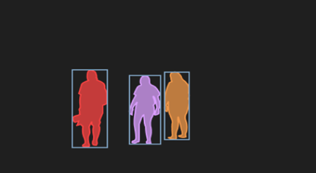
(a) (b)
(c) (d)
Fig. 1. An example that shows what semantic segmentation, instance segmentation, and panoptic segmentation do. (a) Image used for segmentation. (b) The result after utilizing semantic segmentation. (c) The result after conducting instance segmentation. (d) The result after utilizing panoptic segmentation. [1]

  - Introduction to Semantic Segmentation
Semantic segmentation is conducted with a pixel-level prediction, every pixel is classified to its specific category. In recent years, deep learning methods have brought significant improvements to the accuracy of semantic segmentation task. Therefore, deep learning methods are the common solutions for semantic segmentation nowadays.
Methods based on fully convolutional networks (FCN) [11] were considered the state-of-the-art models during the period 2015 to 2020. However, models based on Transformer have been introduced since 2020, and those models have replaced a lot of state-of-the-art models based on FCN. Therefore, currently FCN-based and transformer-based methods are the most popular solutions for the semantic segmentation task.

  - Metrics for Evaluation
After briefly introducing semantic segmentation methods, let’s talk about the evaluation metrics that can evaluate the performance of semantic segmentation methods. The Mean Intersection over Union (MIoU) is the most common performance measurement for semantic segmentation. Before illustrating the MIoU, understanding the Intersection over Union (IoU) is a prerequisite. The Intersection over Union (IoU), also named as the Jaccard index, measures the intersection between the ground truth and the prediction divided by the union between the ground truth and the prediction. (1.1) shows the IoU formula, (1.2) shows the IoU formula in another form.

IoU = $\frac{Groudtruth ∩ Prediction}{Groundtruth ∪ Prediction}$, (1.1)

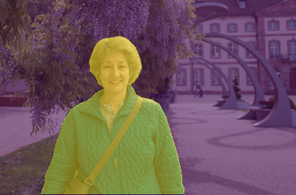
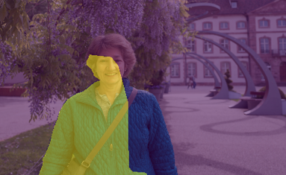
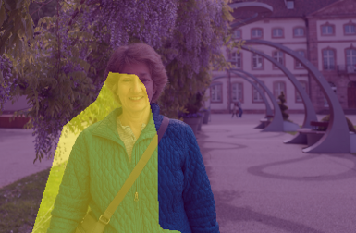
IoU = $\frac{True Positive}{True Positive + False Positive + False Negative }$. (1.2)
(b)
(d)
(c)
(a)

Fig. 2. An example utilized to illustrate the IoU. The woman is the object that we want to identify. Therefore, pixels that are painted yellow are all positive. (a) The ground truth of the image. (b) The prediction of the image. Predict whether the pixels belong to category-woman or not. (c) The intersection between the ground truth of the image and the prediction of the image. The intersection area is painted yellow. (d) The union between the ground truth of the image and the prediction of the image. The union area is painted yellow. [2]

The ground truth category of the object that we want to identify is positive. True positive means the case where a pixel located in the object area is predicted as the right category, in other words, the predicted category of a pixel in the object’s area is same as the ground truth category of a pixel in the object’s area. False positive means a pixel located in the object’s area is predicted as the wrong category. In other words, the predicted category of a pixel in the object’s area is different from the ground truth category of a pixel in the object’s area. False negative means a pixel located outside the object’s area is predicted as the object’s category. In other words, the predicted category of a pixel outside the object’s area is same as the ground truth category of a pixel in the object’s area. From (1.1) and (1.2), we can see that the intersection between the ground truth and the prediction is equivalent to true positive, and the union between the ground truth and the prediction is equivalent to true positive + false positive + false negative. Figure 2(a) shows an example of the ground truth, Figure 2(b) shows an example of the prediction, Figure 2 (c) visualizes the intersection between the ground truth and the prediction (True Positive), and Figure 2(d) visualizes the union between the ground truth and the prediction (True Positive + False Positive + False Negative).
(b)
After the thorough understanding of the Intersection over Union (IoU), the next step is the illustration of the mean Intersection over Union (MIoU). The concept of the MIoU is very simple. The MIoU is calculated by averaging the IoU values over all categories. (2) shows how MIoU is calculated:
$MIoU= \frac{1}{C }$ $\underset{i=1}{\overset{C}{∑}}{IoU}_{i}$, (2)
where ${IoU}_{i}$ = $\frac{{True Positive}_{i}}{{True Positive}_{i} + {False Positive}_{i} + {False Negative}_{i}}$, C denotes the total number of categories, and i denotes the i^{th} category. Take Figure 1 for example, there are four categories in total including category-human, category-sea, category-sand and category-sky. Therefore, C is four and four IoU values are calculated for four categories respectively. After getting four IoU values, the MIoU is calculated by the average of four IoU values. The MIoU is used to evaluate the accuracy of the segmentation method. Besides the accuracy, the computational complexity and parameters of models have also been considered in some papers. The metric utilized to evaluate the computational complexity is called FLOPs. The full name of FLOPs is floating point operations, which is used for calculating the operations of floating point. Parameters can be utilized to evaluate the memory used. Figure 3 summarizes the metrics that are commonly utilized in the semantic segmentation research.
Evaluate the accuracy of the
semantic segmentation model.
MIoU

FLOPs
Evaluate the memory used and the computational complexity of the semantic segmentation model.

Parameters

Fig. 3. A summary of evaluation metrics for semantic segmentation models. Evaluation metrics
include the MIoU, the FLOPs, and the parameters of the model.
- Datasets for Semantic Segmentation
Cityscapes [3], ADE20K [4], Pascal Context [5], and COCO-Stuff [6] are four datasets commonly used to evaluate the performance of semantic segmentation methods. Cityscapes consists of 5000 images, 2975 images for training, 500 images for validation and 1525 images for testing. There are 19 categories in Cityscapes. ADE20K consists of 22210 images, 20210 images for training and 2000 images for validation. There are 150 categories in ADE20K. Pascal context consists of 10103 images, 4998 images for training and 5105 images for validation. There are 59 classes in Pascal Context. COCO-Stuff consists of 164000 images, 118000 images for training and 5000 images for validation. There are 172 categories in COCO-Stuff. Figure 4 gives four example images in the four datasets, respectively.
(b)
(a)
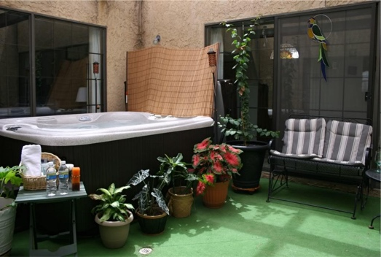
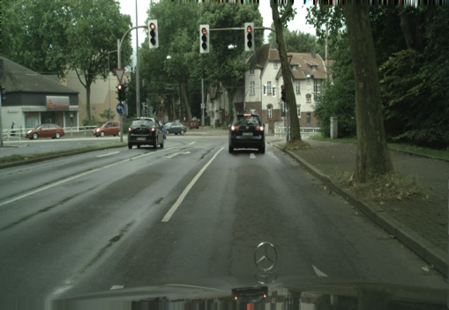
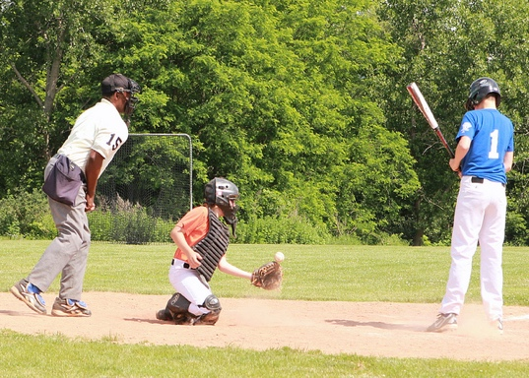
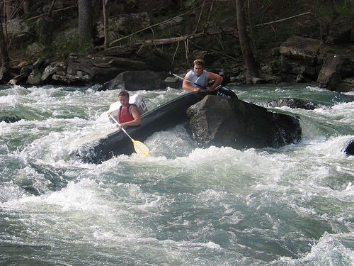
(c)
(d)

Fig. 4. Four example images in four datasets. (a) An image in Cityscapes. (b) An
image in ADE20K. (c) An image in Pascal Context. (d) An image in COCO-Stuff.
[3] [4] [5] [6]

- Semantic Segmentation Methods

3.1 Design Discipline of Semantic Segmentation Methods
When tackling the semantic segmentation problem, common deep neural network designs follow the encoder - decoder structure. The encoder/backbone extracts the features of the image, and the decoder conducts classification for every pixel in the image. Note that both the encoder and the decoder contain multiple layers. In this section, FCN-based semantic segmentation methods and Transformer- based semantic segmentation methods are introduced.

3.2 General Structure of FCN-based Methods
Fully convolutional networks (FCN) [11] are similar to Convolutional neural networks (CNN), the difference between them is that fully connected layers, which are the last few layers of CNN, are not contained in FCN. The encoder of FCN-based methods (Fully convolutional networks) often downsamples the image in order to capture the high-level information and reduce the computational cost. Downsampling includes strided convolutions and pooling. Pooling includes average pooling, max pooling and so on.
Max pooling of size 2
5 | 3 | 2 | 7
4 | 9 | 1 | 5
6 | 1 | 8 | 9
3 | 2 | 5 | 1
9 | 7
6 | 9
Input : 4 $×$ 4
(a)
Average pooling of size 2
5 | 3 | 2 | 7
4 | 9 | 1 | 5
6 | 1 | 8 | 9
3 | 2 | 5 | 1
5.25 | 3.75
3 | 5.75
Input : 4 $×$ 4
(b)
Fig. 5. (a) Max pooling of size 2. (b) Average pooling of size 2.

The process of average pooling is shown in Figure 5(a), and the process of max pooling is shown in Figure 5(b). After images go through multiple transformations of the encoder, low-resolution feature maps are produced. Low-resolution feature maps provide information that can be distinguished between classes. Those low-resolution feature maps are then fed into the decoder to obtain the original-resolution prediction. This process is called upsampling. The reason why upsampling has to be conducted is because semantic segmentation task predicts a class for every image’s pixel, therefore, the prediction map’s resolution cannot be compressed.
There are many methods to perform upsampling, among those approaches, transposed convolution [7] is most widely used. Transposed convolution is also named as fractionally-strided convolution, it expands the smaller matrix into the larger matrix. Suppose that we convolute a 4 $×$ 4 image with a 2 $×$ 2 kernel, stride of 2, and a pad of 1, then we will obtain a 3 $×$ 3 output. To recover the 3 $×$ 3 output to the original image size, we can utilize the transposed convolution with a 2 $×$2 kernel. Figure 6(a) shows the process of the convolution, and Figure 6(b) illustrates the process of the transposed convolution.
apply the convolution with a 2 $×$ 2 kernel, stride of 2

6 $×$ 6 image

padding 1
6 $×$ 6 image
4 $×$ 4 image
3 $×$3 output

(a)
padding 1 and apply the convolution
with a 2 $×$ 2 kernel, stride of 1
Intermediate image
0 | 0 | 0 | 0 | 0 | 0 | 0
0 |  | 0 |  | 0 |  | 0
0 | 0 | 0 | 0 | 0 | 0 | 0
0 |  | 0 |  | 0 |  | 0
0 | 0 | 0 | 0 | 0 | 0 | 0
0 |  | 0 |  | 0 |  | 0
0 | 0 | 0 | 0 | 0 | 0 | 0

 | 0 |  | 0
0 | 0 | 0 | 0 | 0
 | 0 |  | 0
0 | 0 | 0 | 0 | 0
 | 0 |  | 0
3 $×$3 input
4 $×$ 4 output
5 $×$5
7 $×$7

(b)
Fig. 6. An example of how a transposed convolution recover the size of the image. (a) Convolute a 4 $×$ 4 image with a 2 $×$ 2 kernel, stride of 2, and a pad of 1 to obtain a 3 $×$ 3 output. (b) Apply the transposed convolution to the 3 $×$ 3 output produced by the convolution with a 2 $×$ 2 kernel to recover the size of the image.

From Figure 6, we can observe that the first step of the transposed convolution is to create an intermediate image. Because the stride of the convolution is 2, so we have to insert a zero-value pixel between two neighboring pixels (marked in red) of the 3 $×$ 3 input to make sure that their distance is 2. After this process, the size of the image is 5 $×$ 5. Next, we enlarge the 5 $×$ 5 image with maximum number of surrounding zero-value pixels so that the 2 $×$ 2 kernel (marked in green) in the top left corner covers one of the pixels (marked in red) of the 3 $×$ 3 input. In this case, we just need to add a ring of surrounding pixels. Next, we conduct a pad of 1 on the 7 $×$ 7 image . Note that the original convolution utilizes padding to extend the image, while the transposed convolution uses padding to reduce the image. After padding, we obtain a 5 $×$ 5 image, and then we employs the convolution with a 2 $×$ 2 kernel, stride of 1 to acquire a 4 $×$ 4 output which is the same size as the original image. Note that the parameters of the 2 $×$ 2 kernel is learned through the training process and the transposed convolution can't recover the values of the original image, it just recovers the size of the original image. After introducing the general FCN-based structure design for semantic segmentation, now let’s look at several famous FCN-based encoder/backbone designs.

3.3 Backbones/Encoders of FCN-based Methods

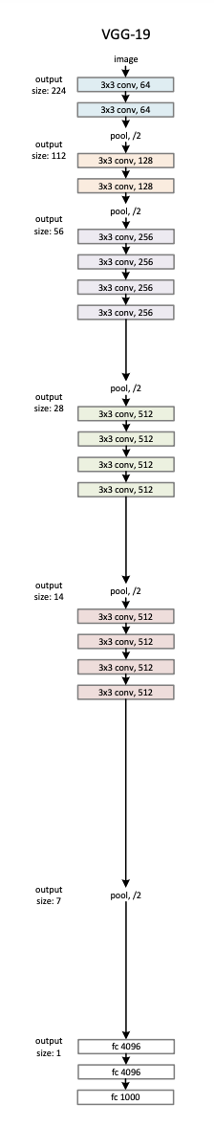
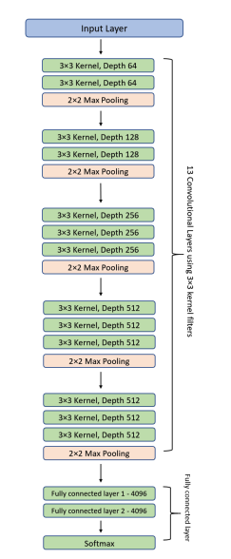
3.3.1 Backbone 1: VGGNet
Fig. 7. Overall structures of VGG-16 and VGG-19. [8]
VGGNet (Visual Geometry Group Network) [8] is a standard convolutional neural network architecture with multiple layers. Among various designs for VGGNet, VGG-16 and VGG-19 are the top two models that are widely adopted. VGG-16 consists of 16 layers (13 convolutional layers and 2 fully connected layers and 1 Softmax classifier) and VGG-19 is made of 19 layers (16 convolutional layers and 2 fully connected layers and 1 Softmax classifier). The overall structures of VGG-16 and VGG-19 are illustrated in Figure 7. From Figure 7, we can observe that the size of each convolutional kernel in a convolutional layer is 3 $×$ 3 and the size of max pooling is 2. Furthermore, as layers go deeper, channels of feature maps are increased up to 512.

3.3.2 Backbone 2: ResNet
People may intuitively think that deeper networks may improve the model performance. However, deeper networks are more difficult to optimize, it may degrade the model performance. Figure 8(a) shows this circumstance, we can observe that the training error and the test error of the deep neural network with 56 layers are both higher than the deep neural network with 20 layers. In order to solve this issue, Residual Network (ResNet) [9] was proposed. ResNet consists of several residual learning blocks. The design of a residual learning block is shown in Figure 8(b). From Figure 8(b), we can see that x and $F$(x) are added together with a shortcut connection in a residual learning block .
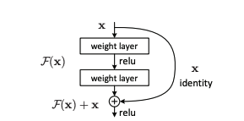
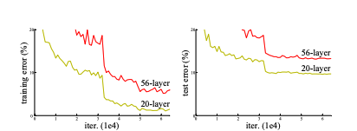
- (b)
Fig. 8. (a) The training errors of the deep neural networks with 20 layers and 56 layers on CIFAR-10(left). The test errors of the deep neural networks with 20 layers and 56 layers on CIFAR-10. (right). (b) A residual learning block. [9]

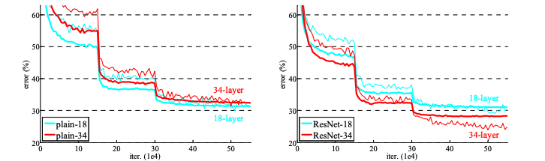
With residual learning blocks, very deep neural networks are easy to optimize. In other words, deeper network with residual learning blocks can improve the model performance/accuracy. Figure 9 shows the comparison between the deep neural networks without residual learning blocks (18 layers and 34 layers) and deep neural networks with residual learning blocks (18 layers and 34 layers).
- (b)
Fig. 9. (a) The training error (thin curve) and the validation error (thick curve) of the deep neural networks without residual learning blocks (18 layers and 34 layers). (b)The training error (thin curve) and the validation error (thick curve) of the deep neural networks with residual learning blocks (18 layers and 34 layers). [9]

The left subfigure in Figure 9 shows that the training error and the validation error grow higher as the neural network without residual learning blocks are deeper (18 layers to 34 layers). On the other hand, the right subfigure in Figure 9 shows that the training error and the validation error grow lower as the neural network with residual learning blocks (ResNet) are deeper (18 layers to 34 layers). Furthermore, the training error and the test error of ResNet with 34 layers are lower than all the other three models. This phenomenon indicates that deeper network can enhance the model performance with the assistance of residual connection, therefore, the model can be designed with significantly deep layers. There are totally five ResNet structures proposed in this paper (ResNet-18, ResNet-34, ResNet-50, ResNet-101, Res-152, where number indicates quantity of layers), Figure 10 demonstrates the structure of ResNet-34, which incorporates 16 residual learning blocks (each residual learning block contains two convolutional layers and a shortcut connection).

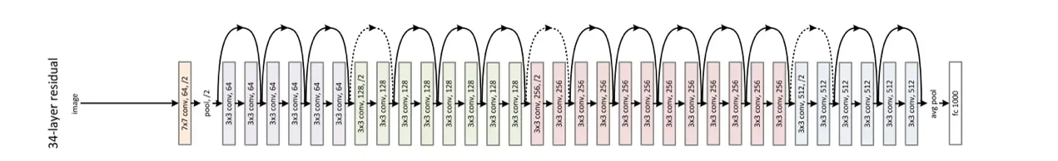
Fig.10. The structure of ResNet-34 [9]

Table 1 shows the detail designs of ResNet-18, ResNet-34, ResNet-50, ResNet-101, and Res-152. Noted that the input image size is 224 $×$ 224.

Table 1. The detail designs of ResNet-18, ResNet-34, ResNet-50, ResNet-101, and Res-152. [9]
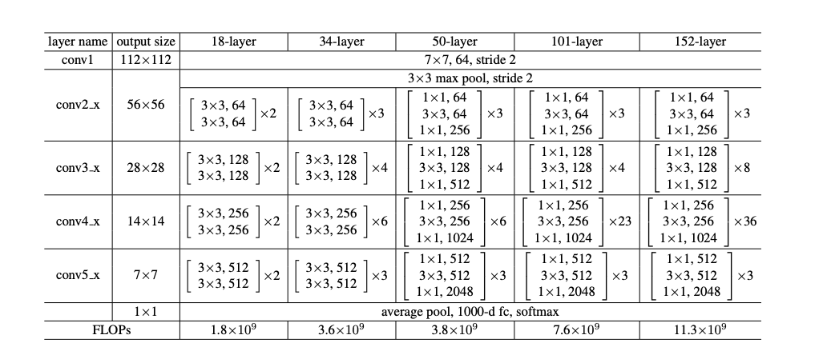

3.3.3 Backbone 3: HRNet
As stated above, most encoders are high-to-low resolution networks, the outputs of those encoders are low-resolution representations. Different from those networks, the HRNet (High-Resolution Net) [10] maintains high-resolution representations through the whole process, the overall structure of the HRNet is demonstrated in Figure 11.
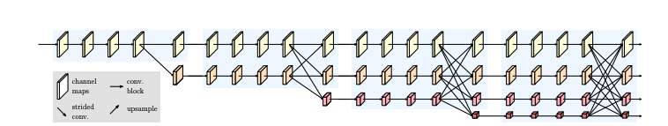
Fig.11. The structure of the HRNet . There are four rows. The first row consists of high-resolution convolutions. The second row consists of second-resolution convolutions. The third row is made up of third-resolution convolutions, and the fourth row consists of fourth-resolution convolutions. [10]

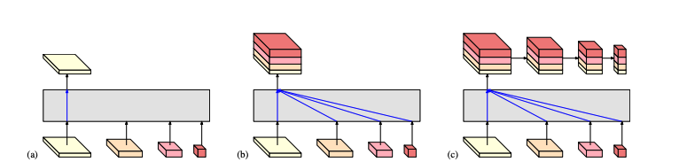
There are three versions of HRNet. One is HRNetV1, the other two are HRNetV2 and HRNetV2p. HRNetV1 is utilized for human pose estimation, it only uses the output from the high-resolution convolutions (the first row in Figure 10) to conduct the estimation. HRNetV2 is used for estimating segmentation maps and facial landmark heatmaps, it concatenates outputs from all four rows to conduct the prediction. This simple modification of HRNetV1 enables the model to extract stronger high-resolution representations. HRNetV2p is applied to object detection, it not only concatenates outputs from all four rows but also downsamples them to conduct the object detection. Figure 12 visualizes the difference between those three models.
Fig.12. Those four-resolution representations are the outputs from the network in Figure 11. (a) In HRNetV1, only the high-resolution representation is utilized. (b) In HRnetV2, those four-resolution representations are all concatenated and utilized. Note that the second-resolution representation, the third-resolution representation and the fourth -resolution representation are all upsampled to the high-resolution for the concatenation. (c) In HRnetV2p, those four-resolution representations are all concatenated and downsampled. [10]

The advantage of the HRNet is that it extracts strong high-resolution representations, therefore, it can lead to performance improvement on various vision tasks including human pose estimation, semantic segmentation, object detection, and so on.

3.4 FCN-based Semantic Segmentation Methods
After illustrating several backbones/encoders of FCN-based methods, this section starts to introduce several FCN-based methods designed for semantic segmentation.

3.4.1 Method 1: Fully convolutional Network
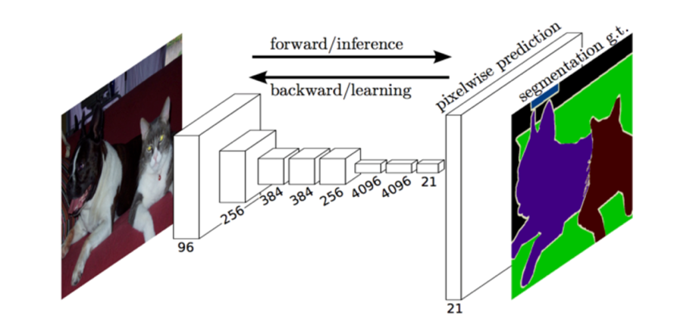
Fully convolutional network (FCN) [11] designed for pixel- by- pixel segmentation task was published in 2014, which is the origin of FCN-based semantic segmentation methods.
Fig. 13. Network designed in [11].
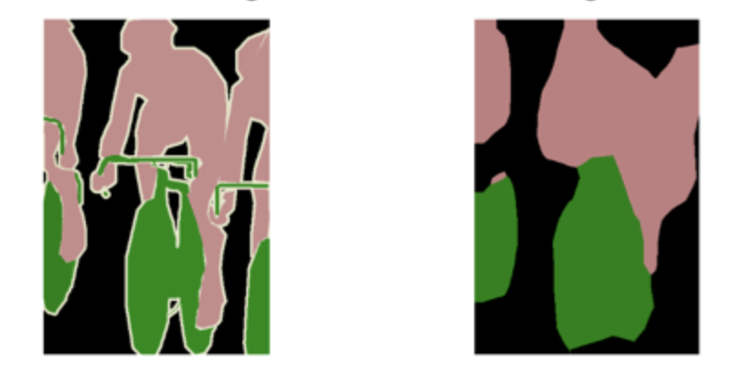
In this paper, authors utilized the well-known image classification architecture such as AlexNet, VGG Net or GoogLeNet as the encoder unit, and the decoder unit with transposed convolution layers are added to deconvolute output feature maps of the encoder. The network design is shown in Figure 13. The problem of this design is that transposed convolution cannot produce the fine-grained segmentation result. The reason is because the input’s resolution of the decoder has already been compressed by the encoder. Therefore, it is very difficult for the decoder to make the prediction. Figure 14 shows the predicted segmentation of this network design.
- (b)
Fig. 14. (a) Ground truth (b) The predicted segmentation based on the network design in Figure 12. [11]

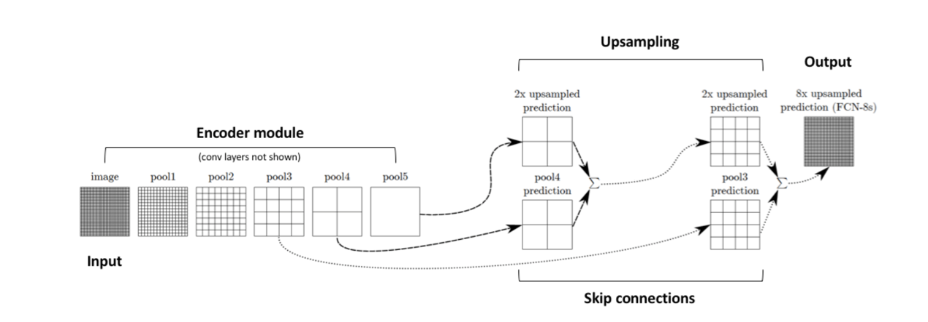
From Figure 14, we can observe that the predicted result is not accurate at all. To solve this issue, authors in this paper proposed another network architecture. It upsamples the encoded information progressively instead of upsampling the encoded information rapidly to the original resolution. Furthermore, it also adds the outputs of the intermediate encoder layers to the upsampled feature maps. This can enable the network to make more precise predictions because the outputs of the intermediate encoder layers preserve more details of the image. The overall architecture is shown in Figure 15. Figure 15 quotes from [12].
Fig. 15. The network design that incorporates the encoder information. [12]
Figure 16(c) shows the predicted result based on this modified network structure. We can observe that compared to Figure 16(b), which shows the segmented prediction based on the network design in Figure 13, the prediction in Figure 16(b) is more accurate and its boundary shape is more similar to the ground truth in Figure 16(a).
- (b) (c)
Fig. 16. (a) Ground truth (b) The segmented prediction based on the network design in Figure 12, it only incorporates high-level (coarse) information when producing the predicted result. (c) The segmented prediction based on the modified network structure. It upsamples progressively and it incorporates low-level (fine) information from the intermediate encoder layers and high-level (coarse) information when producing the predicted result. [11]

3.4.2 Method 2: U-Net
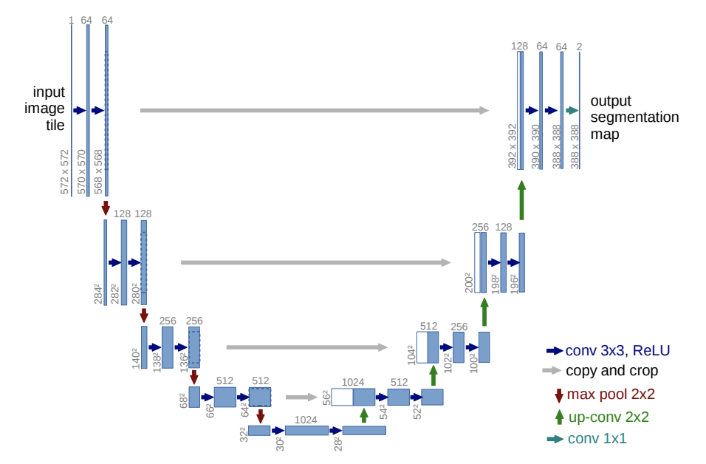
In 2015, Ronneberger, Fischer, and Brox proposed the U-Net architecture [13] that can make more fine-grained segmented predictions. The design idea is similar to Figure 15, it incorporates the intermediate encoder layers to make more fine-grained predictions. The architecture design is shown in Figure 17.
Fig. 17. The U-Net architecture. The architecture design is symmetry. [13]

From Figure 17, We can observe that the U-Net architecture is symmetry, and it incorporates all the low-level and high-level information to conduct the segmented prediction. This structure has been widely utilized since its publication.

3.4.3 Method 3: DeepLabv3+
Dilated / Atrous Convolution
Previous works used pooling to downsample the image. A benefit of pooling an image is that it reduces the computational complexity. Another benefit is that it increases the receptive field during the pooling process. Increasing the receptive field means that it can retrieve high-level information from the image, which is useful for semantic segmentation task. However, pooling has its problem. The problem is that pooling discards multiple pixels. In other words, it reduces the spatial resolution of the image.
In order to solve this issue, Fisher Yu and Vladlen Koltun proposed a method [14] called dilated/atrous convolution to increase the receptive field while maintaining the spatial resolution of the image simultaneously. The visualization of dilated/atrous convolution is shown in Figure 18.
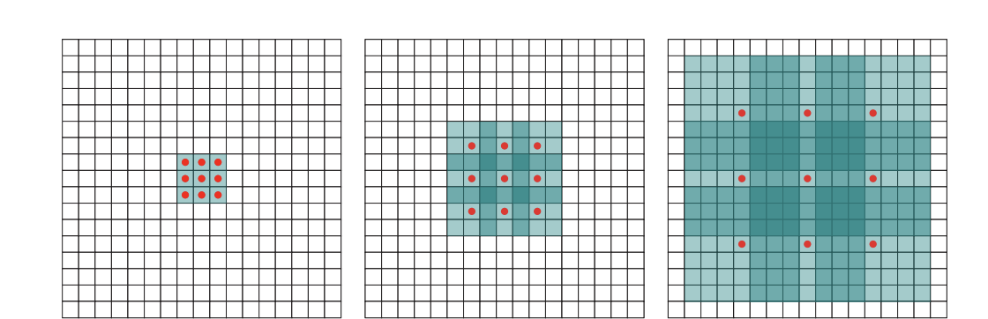
(a) (b) (c)
Fig. 18. The visualization of dilated/atrous convolution. (a) The 1-dilated convolution kernel (bounded by a black frame). The receptive field is 3 $×$ 3 (I1). (b) The 2-dilated convolution kernel (bounded by a black frame). The receptive field is 7 $×$ 7 (I2). (c) The 4-dilated convolution kernel (bounded by a black frame). The receptive field is 15 $×$ 15 (I3). [14]

From Figure 18, we can observe that the size of 2- dilated convolution kernel is 5 $×$ 5, and the interval between two red circle points is 1 (dilation rate is 1). The size of 4- dilated convolution kernel is 9 $×$ 9, and the interval between two red circle points is 3 (dilation rate is 3). The size of n- dilated convolution kernel is (2n +1) $×$ (2n + 1), and the interval between two red circle points is n - 1(dilation rate is n -1). Note that the pixel values in dilated kernels (bounded by the black frames in Figure 18) are all zero between two red circle points.
Suppose that layer 1 is 1 – dilated convolution, layer 2 is 2 – dilated convolution, layer 3 is 4 – dilated convolution, I0 is the input image, I1 is the output of layer 2, and I2 is the output of layer 3. Due to the characteristic of dilated convolution, we can know that I1 has a receptive field of 3 $×$ 3, I2 has a receptive field of 7 $×$ 7, and I3 has a receptive field of 15 $×$ 15. The receptive field of I1, I2 and I3 can be seen from Figure 18(a), Figure 18(b) and Figure 18(c) respectively.
In conclusion, the receptive field rises exponentially as the parameters increase linearly. The characteristic of dilated convolution is desirable, it increases the receptive field rapidly while maintaining the spatial details.
Atrous Spatial Pyramid Pooling (ASPP)
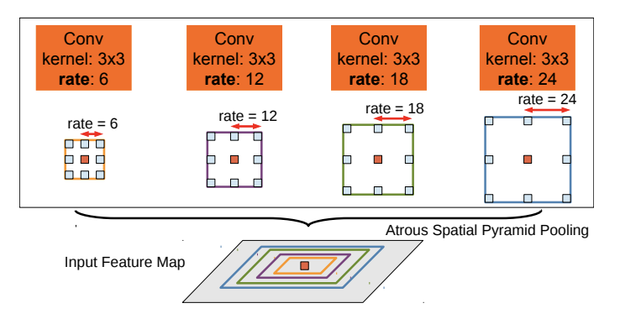
Based on the dilated/atrous convolution, L. C. Chen et al. proposed a method called atrous spatial pyramid pooling (ASPP) [15] to increase the receptive field and extract multi-scale features. Classification based on multi-scale features can boost the performance of semantic segmentation. The reason is that it enhances the network’s capability to identify small and large objects in images. Figure 19 shows the process of ASPP. From Figure 19, we can observe that multiple atrous/dilated convolution kernels with different dilated rates are utilized to extract multi-scale features, and the orange/center pixel is classified based on those multi-scales features
Fig. 19. Atrous spatial pyramid pooling (ASPP). The orange/center pixel is classified based on multi-scale features. Multi-scale features are extracted by the atrous/dilated convolution kernels with different dilated rates.[15]

In 2018, based on atrous spatial pyramid pooling (ASPP) and encoder – decoder structure, Liang-Chieh Chen, Yukun Zhu, George Papandreou, Florian Schroff, and Hartwig Adam from Google Inc proposed DeepLabv3+ [16]. DeepLabv3+ achieves about 80% mIoU on Cityscapes. Figure 20 demonstrates the overall structure of DeepLabv3+.
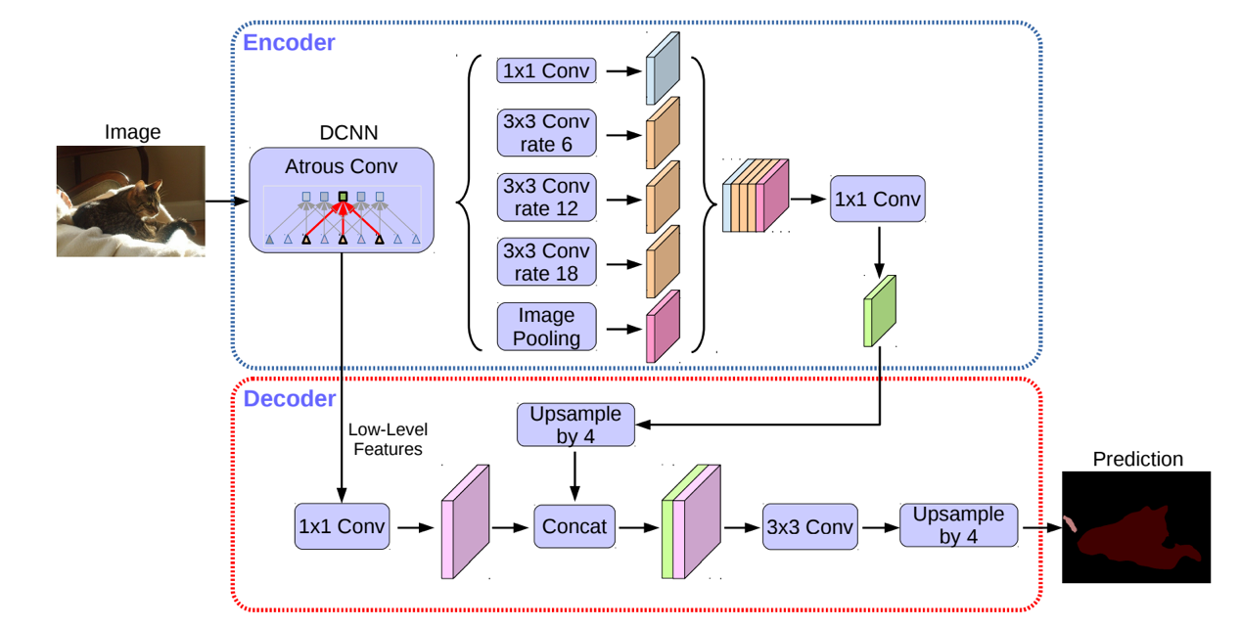
Fig. 20. The structure of DeepLabv3+. The encoder consists of the deep convolutional neural network and the atrous spatial pyramid pooling (ASPP). The encoder employs dilated/atrous convolutions. The decoder upsamples the features gradually and combines both low-level features and high-level features to conduct the prediction. [16]

From Figure 20, we can observe that the encoder extracts features by atrous convolutions. It also incorporates the atrous spatial pyramid pooling module to extract multi-scale features. After multi-scale features are concatenated, 1 $×$ 1 convolutional kernel is applied to aggregate those multi-scale features to obtain the encoder’s output. Note that in this paper [16], the authors adopted the depthwise atrous seperable convolution instead of the traditional convolution to reduce the computational cost while maintaining the performance of the segmented result. The process of the depthwise seperable convolution is shown in Figure 21 and the process of the traditional convolution is shown in Figure 22. A depthwise seperable convolution consists of a depthwise convolution and a pointwise convolution. A depthwise convolution utilizes a single filter to convolute each channel of the image. After obtaining the outputs from the depthwise convolution, a pointwise convolution uses 1 $×$ 1 convolutions to aggregate the outputs’ pixel values across the channels. The depthwise atrous seperable convolution means that the kernels utilized for the depthwise convolution are the dilated/atrous kernels.
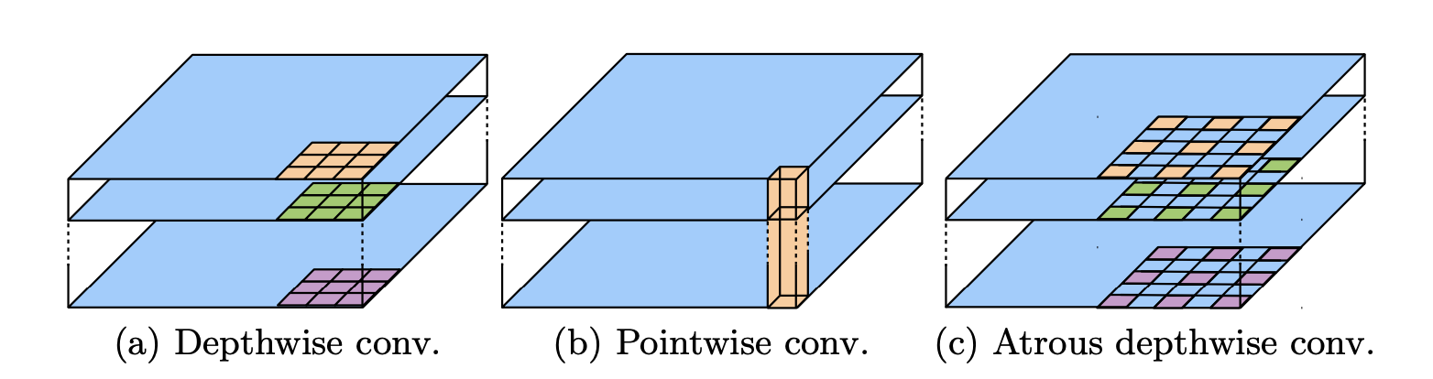
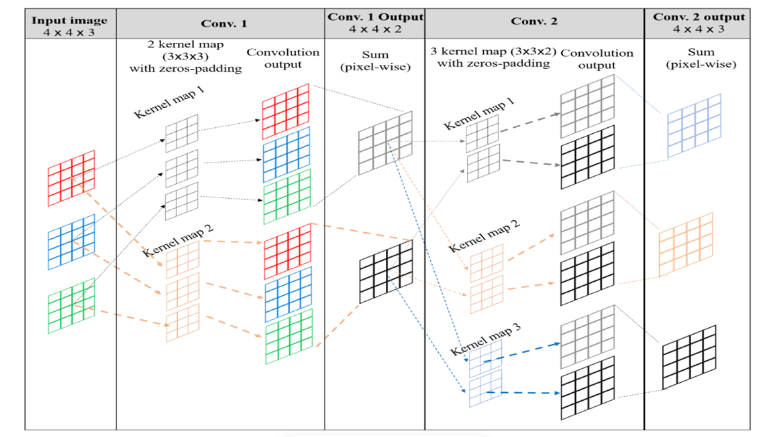
Fig. 21. The process of the depthwise seperable convolution. A depthwise seperable convolution consists of a depthwise convolution and a pointwise convolution. (a) Depthwise convolution. (b) Point wise convolution. (c) Atrous depthwise convolution. [16]
Fig. 22. The process of the traditional convolution. A kernel map incorporates same number of channels as the input image. The quantity of kernel maps decides the channels of the convolutional output. [17]

Suppose that the size of the input image is H $×$ W $×$ C and there are $C_{k}$ kernel maps (each kernel map’s size is k $×$ k $×$ C). Based on this assumption, we can infer that the output’s size of the traditional convolution is H $×$ W $×$ $C_{k}$, the output’s size of the depthwise convolution is H $×$ W $×$ C , and the output’s size of the pointwise convolution is H $×$ W $×$ $C_{k}$. Based on this derivation, we can conclude that depthwise seperable convolution can have similar effect as the traditional convolution. Now let’s compare the computational complexity between the traditional convolution and the depthwise seperable convolution. The computational complexity of the traditional convolution is H $×$ W $×$ C $×$k $×$k $× C_{k}$. The computational complexity of the depthwise separable convolution is H $×$ W $×$ C $×$k $×$k + H $×$ W $×$ C $× C_{k}$. The depthwise convolution’s computational complexity is H $×$ W $×$ C $×$k $×$k, and the pointwise convolution’s complexity is H $×$ W $×$ C $× C_{k}$. The ratio of the depthwise separable convolution’s computational complexity to the traditional convolution’s computational complexity is shown as in (3).

$$\frac{The computational complexity of the depthwise seperable convolution }{The computational complexity of the traditional convolution}$$

= $\frac{H × W × C × k × k + H × W × C × C_{k} }{H × W × C × k × k × C_{k}}$
= $\frac{1}{C_{k}}$ + $\frac{1}{k × k }$ (3)

From (3), we can observe that the computational complexity of the depthwise separable convolution is lower than the traditional convolution. As the quantity and size of kernel maps get larger, the ratio becomes smaller. In conclusion, the depthwise separable convolution has the similar effect as the traditional convolution. Furthermore, it also saves the computational time. Therefore, the depthwise separable convolution can replace the traditional convolution. After the thorough illustration of the encoder of DeepLabv3+, now let’s turn to the decoder. The decoder of DeepLabv3+ recovers the spatial resolution gradually, from Figure 19 we can observe that the encoder features (the output of the encoder) are bilinearly upsampled progressively, and it also concatenates low-level features to conduct the segmented prediction that is more precise.

3.4.4 Method 4: UPerNet
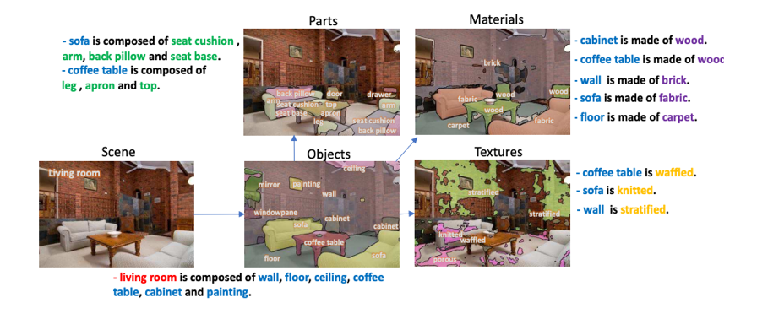
Unified Perceptual Parsing Network (UperNet) [18] was proposed in 2018.This network was trained in order to capture various information of the image just like the human visual system. Humans can retrieve a lot of information, which includes scene, objects, parts, textures and materials, from the image. Figure 23 shows an example. Scene, objects, parts, textures and materials are all illustrated in this figure.
Fig. 23. The visualization of scene, objects, parts, textures and materials. UperNet is trained to parse scene, objects, parts, textures and materials simultaneously. [18]
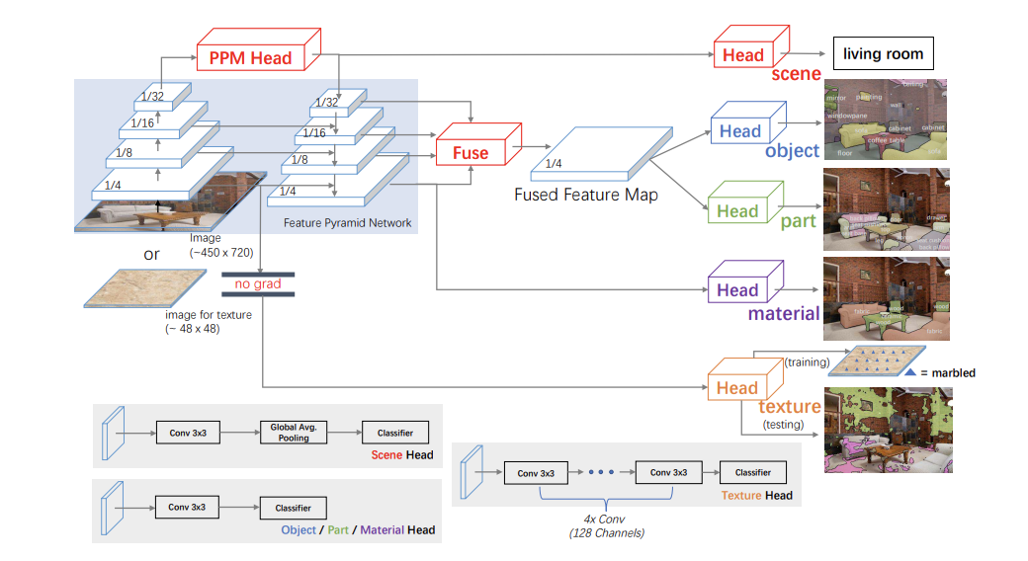
The training dataset for the UPerNet is Broadly and Densely Labeled Dataset (Broden) [19]. Broden incorporates a wide range of scenes, objects, parts, materials and textures. The network structure of the UPerNet is demonstrated in Figure 24.
Fig. 24. The network structure of the UPerNet. The UperNet consists of a feature pyramid network (FPN), a pyramid pooling module (PPM), and several heads. [18]

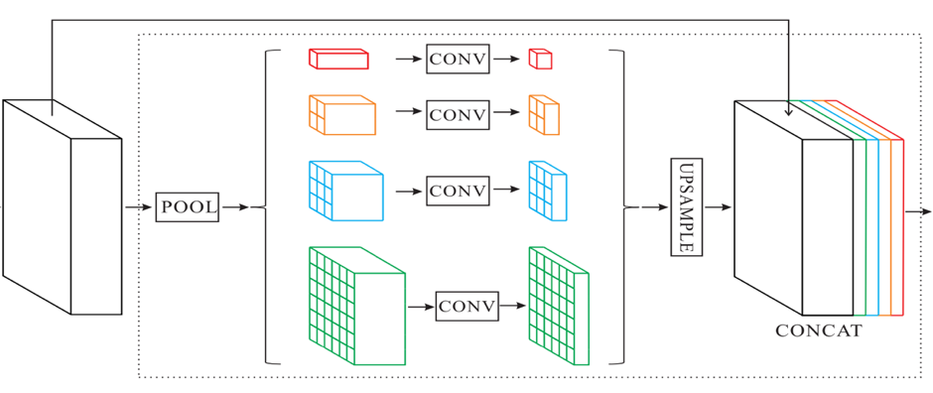
From Figure 24, we can notice that the UperNet contains a feature pyramid network (FPN), a pyramid pooling module (PPM), and several heads. The structure of the feature pyramid network is top-down, which is similar to the shape of the pyramid. It incorporates the information of high-level features, middle-level features and low-level features to conduct the segmented prediction that is more precise. The pyramid pooling module from the PSPNet [20] was proposed in 2017. Zhou et al. In paper [21], Zhou, Bolei, et al have shown that the receptive field of deep CNN is not large enough, therefore, the purpose of appending the pyramid pooling module is to expand the receptive field. With the assistance of the pyramid pooling module, the network can extract more global information. The structure of the pyramid pooling module is shown in Figure 25.
(a) Feature Map (b) Pyramid Pooling Module
Fig 25. The structure of the pyramid pooling module. [20]
From Figure 25, we can notice that the pyramid pooling module generates global features with different scales and fuses them together to form the robust global feature map. Due to the different characteristics of scenes, objects, parts, materials, and textures, different heads are designed to conduct predictions for those five categories. The scene head consists of a convolutional layer, a global average pooling layer, and a linear classifier. The input of the scene head is the output of the pyramid pooling module, this design is reasonable because global information is required for the identification of the scene. The object head, the part head and the material head all consist of a convolutional layer and a linear classifier. To identify objects and parts, low-level and middle-level information are required because they can provide more spatial details. Therefore, the input of the object head and the part head is a fused feature map which contains all feature maps of the feature pyramid network. To identify materials, low-level/local features are the most important information, therefore, the input of the material head is the feature map with the highest resolution. The texture head consists of several convolutional layers and a linear classifier. To identify textures, only the lowest features are required, it doesn’t require any high-level information. Therefore, the input of the texture head is the first layer of the encoder. Furthermore, texture label is based on non-natural images, and those non-natural images are quite different from other images trained for scenes, objects, parts and materials. Therefore, to avoid influencing the performance of other tasks, the gradient of this branch is refrained from back-propagating to the layers of backbone networks.

3.4.5 Method 5: EncNet
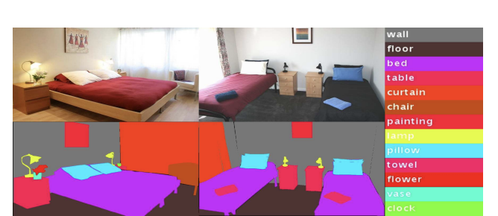
Context Encoding Network (EncNet) [22] was proposed in 2018.
Fig 26. With the prior knowledge of the scene (bedroom), the possible
categories of objects can be refined (wall, floor, bed, table, curtain …). [22]

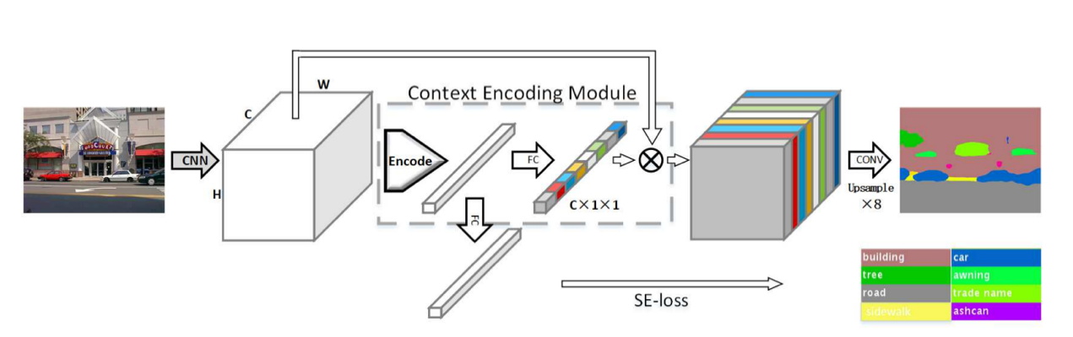
The design concept of the EncNet is to capture the global scene semantic information first and then conduct the classification based on the global scene semantic information. Take Figure 26 for example, if the EncNet can identify that the bedroom is the scene first, then it can refine categories of objects in the image to specific categories. Specific categories include bed, laptop, floor, wall, chair, etc. In other words, categories such as car, boat and airplane can be excluded with the prior knowledge of the scene. With the refinement of categories, it improves the performance of semantic segmentation. The structure of the EncNet is shown in Figure 27.
Fig 27. The structure of the EncNet. [22]

The pretrained convolutional neural network (CNN) is utilized in the first component of the EncNet to extract dense feature maps of the image. The second component of the EncNet is the context encoding module, which is the main contribution of this paper. The context encoding module contains the encoder layer, which is utilized to capture the global semantic information. The output of the context encoding module is called encoded semantics. Encoded semantics are then fed into two branches. One branch is utilized to make the encoder layer learn the global semantic information. In order to achieve this goal, semantic encoding loss (SE-loss) is introduced. SE-loss is calculated as binary cross entropy loss, which enables the network to identify which objects are in the scene. The other branch is employed to obtain scaling factors that can strengthen or weaken class-dependent feature maps. For example, if a scene is the railway, then the probability of a train in this scene is strengthened, but the probability of a helicopter in this scene is weakened. Note that scaling factors are visualized in colors in Figure 27. Those strengthened or weakened feature maps are then upsampled to conduct the per-pixel predicted segmentation. The EncNet was conducted on PASCAL-Context, and ADE20K to evaluate its performance. From those experimental results, they have shown that the design structure of the EncNet really improves the performance of the segmentation results.

3.4.6 Method 6: CCNet
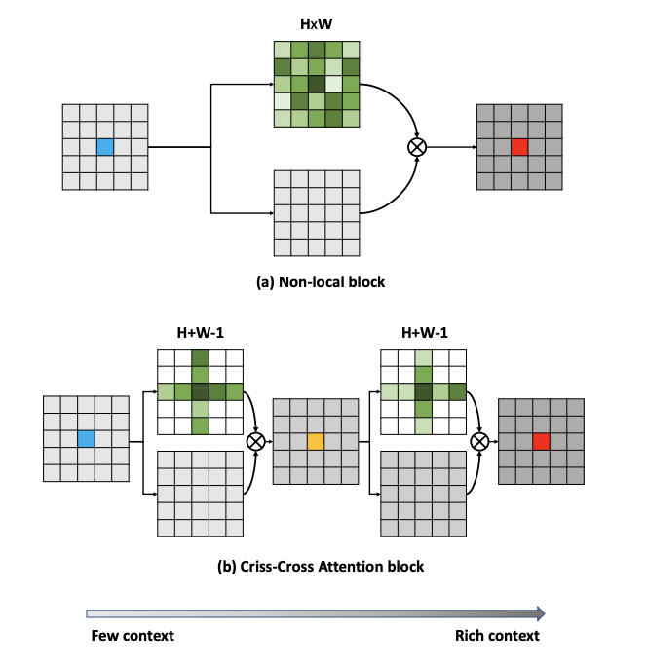
Traditionally, when capturing the long-range information of the image, numerous convolutional layers are stacked to obtain the large receptive field. However, doing in this way is computationally inefficient. Furthermore, the size of the receptive field for the CNN is also restricted, this means that CNN has its limitation on exploiting the long-range dependencies. To solve this issue, the non-local block in the Non-local network [23] is proposed to capture the global information in an efficient way. A non-local block utilizes a self-attention mechanism to capture dense and rich contextual information. The details of the self-attention mechanism will be introduced in the Transformer section. Although a non-local block can retrieve the semantic information of the whole image and is more efficient than deep stacks of convolutional layers, it still requires considerable computational time and space. The time complexity and the space complexity of a non-local block are both $Ο\left(\left(H × W\right) × (H × W)\right)$, where H is the height of the image and W is the width of the image. In order to reduce the considerable computational time and space, Criss-Cross Network [24] was proposed in 2019 to capture the global contextual information in an efficient way. A criss-cross attention block in Criss-Cross Network reduces time complexity and space complexity from $Ο\left(\left(H × W\right) × (H × W)\right)$ to $Ο\left(\left(H × W\right) × (H+W-1)\right)$. Figure 28 shows the difference between the non-local block and the criss-cross attention block.
Fig 28. Comparison between the non-local block and the criss-cross attention block [24]

From Figure 28, we can observe that the non-local block utilizes a brute-force approach to retrieve the global contextual information. It directly calculates the relationship between an arbitrary pixel and all the other pixels in the image. The time complexity and the space complexity of this process are $Ο$(H $×$ W), and because all pixels of the image have to go through this process, therefore, the time complexity and the space complexity of the non-local block are both $Ο\left(\left(H × W\right) × (H × W)\right)$. A criss-cross attention block consists of two criss-cross attention modules. Each criss-cross attention module explores the relationship between an arbitrary pixel and the other pixels that are in the same column or the same row as the arbitrary pixel in the image. The time complexity and the space complexity of this process are $Ο$(H $+ W-1$), and because all pixels of the image have to go through this process, therefore, the time complexity and the space complexity of a criss-cross attention module are both $Ο\left(\left(H × W\right) × (H+W-1)\right)$. The first criss-cross attention module retrieves the contextual information in vertical and horizontal directions. In order to capture the full-image contextual information per pixel, the output of the first criss-cross attention module is fed into another criss-cross attention module. By doing this, criss-cross attention block can explore the relationship between an arbitrary pixel and all the other pixels in the image. Because a criss-cross attention block contains two criss-cross attention modules and each module’s time complexity and space complexity are both $Ο\left(\left(H × W\right) × (H+W-1)\right)$, therefore, the time complexity and the space complexity of a criss-cross attention block are both $Ο\left(\left(H × W\right) × (H+W-1)\right)$ too. In conclusion, a criss-cross attention block can collect global contextual information just like the non-local block; furthermore, it is much more efficient. The overall structure of the CCNet is shown in Figure 29.
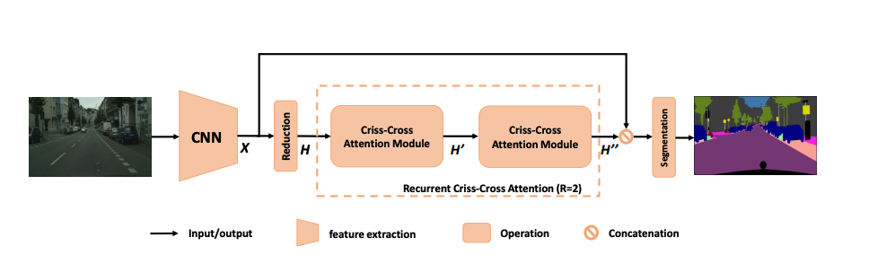
Fig 29. The architecture of the CCNet. [24]

From Figure 29, we can observe that the image is first fed into the CNN to extract local feature maps X. X are then dimensionally reduced to H. Next, H is fed into a criss-cross attention block to obtain dense and rich global feature maps $H^{''}$. This process is also called Recurrent Criss-Cross Attention (RCCA). Note that R = 2 because there are two cross-cross attention modules. X and $H^{''}$ are then concatenated together and fed into the segmentation layer/decoder to conduct the semantic segmentation.

3.4.7 Method 7: OCRNet
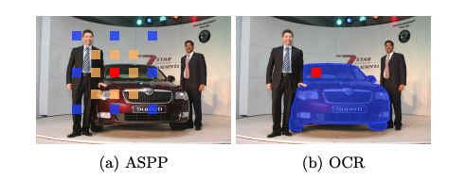
Object-Contextual Representations Net (OCRNet) [25] explores the relation between each pixel and each object region, which is different from the multi-scale designs such as ASPP and PPM. Figure 30 visualizes their difference. From Figure 30, we can observe that ASPP is calculated by the relations between each pixel (take red-color pixel for example) and its surrounding pixels with different spatial positions, and OCR is computed by relations between each pixel (take red-color pixel for example) and different object regions. This elaborated design boosts the model performance on the semantic segmentation task.
Fig 30. Difference between ASPP and OCR. (a) ASPP is calculated by relations between each pixel (take red- color pixel for example) and its surrounding pixels (skin-color pixels and blue-color pixels) with different spatial positions. Note that different color pixels correspond to different dilation rates. (b) OCR is computed by relations between each pixel (take red-color pixel for example) and different object regions. In this figure, object regions include car (masked in blue pixels), human, floor, and so on. [25]

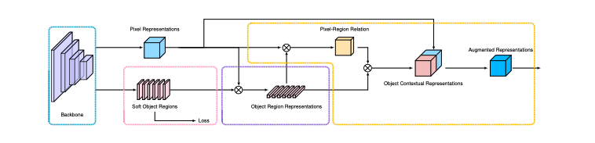
The architecture of the Object-contextual representation Net (OCRNet) is shown in Figure 31.
Fig 31. The architecture of the OCRNet. [25]

First, the image is fed into the backbone network (ResNet or HRnet, blue bounding box) to obtain K soft object regions (pink bounding box). The backbone network is trained supervisedly on the groundtruth segmentation dataset. Next, the representation for each object region $f_{k}$is calculated by weighted averaging the pixels in the corresponding kth object region (purple bounding box). After the representation for each object region is obtained, the OCR(Object-contextual representation) can be computed by weighted averaging all the object region representations. The weights for calculating the OCR are pixel-region relations. Each weight stands for the relation between a pixel and an object region ($w_{i,k})$. Finally, each pixel is augmented with its OCR to obtain the augmented representations. (yellow bounding box). The complete process for the OCRNet can be formulated as in (4) [25]:
(4)
$y_{i}$ = $ρ(\overset{K}{\underset{k=1}{Σ}} w_{i,k}δ$($f_{k}$)), (4)
where$ρ$ and $δ$ are transformation functions (function structure: 1$× 1 convolution → Batch Normalization →ReLU$), $f_{k}$ is calculated by (5) [25] , and $w_{i,k}$ is computed by (6) [25].
(5)
$f_{k}$ = $\underset{i ∈I}{∑}{\tilde{m}}_{k,i}x_{i}$.
$Ι$ in (5) stands for the image. As illustrated above, the backbone network can produce K soft object regions. Those K soft object regions are represented by K maps {$M_{1}$, $M_{2}$, … , $M_{K}$}. Each map $M_{k}$ is a 2D segmentation map . The value of each pixel
(pixel i ) indicates the degree that a pixel (pixel i ) is belong to class k, and ${\tilde{m}}_{k,i}$ is the normalized value of pixel i.
$w_{i,k}$ = $\frac{e^{κ(x_{i},f_{k})}}{\underset{j=1}{\overset{K}{∑}}e^{κ(x_{i},f_{j})}}$,
(6)
where $κ\left(x,f\right)=$ ${ϕ(x)}^{T}ψ$(f), and $ϕ$ and $ψ$ are two transformation functions (function structure: 1$× 1 convolution → Batch Normalization →ReLU$). The final step can be formulated as in (7) [25]:
(7)
$z_{i}$ = g(${[x_{i}^{T} y_{i}^{T}]}^{T}$),
where $x_{i}$ is the pixel representation obtained from the backbone network and $y_{i}$ is the object contextual representation and g is a transformation function (function structure: 1$× 1 convolution → Batch Normalization →ReLU$).

3.5 Introduction of the Transformer
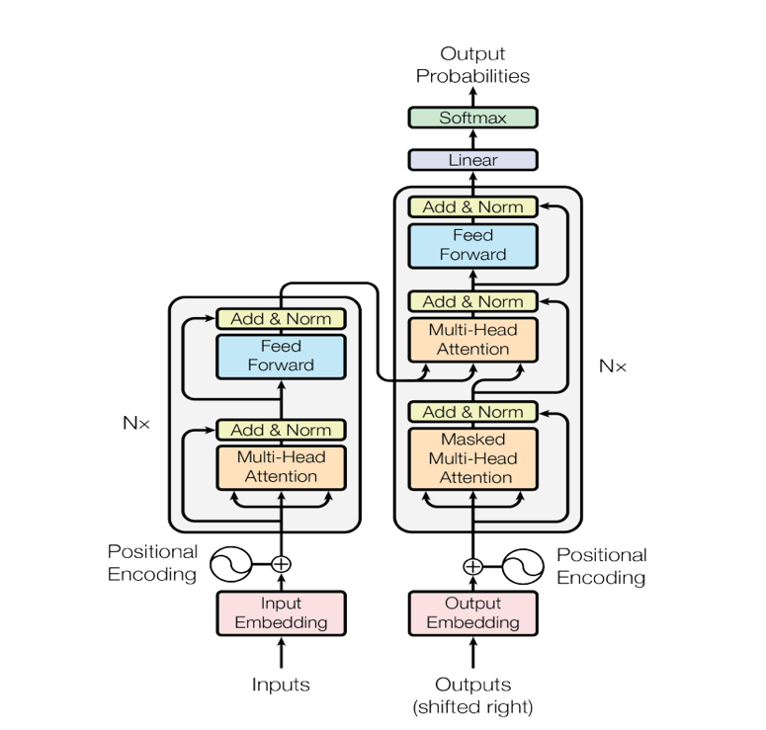
After introducing FCN-based semantic segmentation methods, now let’s turn to Transformer-based semantic segmentation methods. Before diving into transformer-based semantic segmentation methods, we have to understand Transformer first. Transformer [26] is widely utilized in the field of natural language processing. Due to its success in NLP, researchers are curious about whether this structure can succeed in the field of computer vision or not. From 2020, more and more researchers attempt to employ Transformer-based structures to tackle the semantic segmentation task. A Transformer includes an encoder and a decoder. The overall structure of a Transformer is shown in Figure 32.
Decoder
Encoder
Fig 32. The overall structure of a Transformer. [26]

From Figure 32, we can observe that a Transformer contains an encoder and a decoder, and both of them contains multiple muti-head attention layers and fully connected layers. The multi-head attention incorporates a few scaled dot-product attentions as shown in Figure 33 (b). The operation of the scaled dot-product attention is visualized in Figure 33 (a).
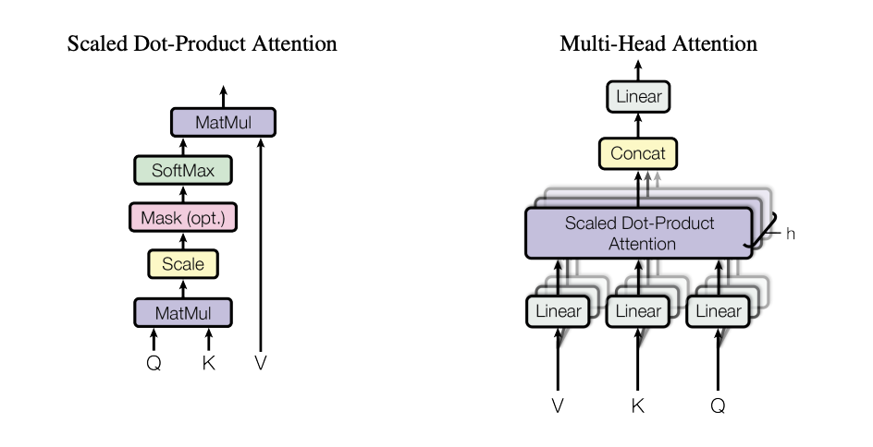
(a) Scaled Dot-Product Attention (b) Multi-Head Attention
Fig 33. The visualization of the scaled dot-product attention and the multi-head attention. [26]

Scaled dot-product attention (Self attention)
The input of the scaled dot-product attention consists of keys (K), queries (Q) and values (V). Those three things are produced by the embedding layer and they are all vectors. Figure 33 shows an example of the scaled dot-product attention. We can observe that the original input vectors $α^{1}$, $α^{2}$, $α^{3},$ $α^{4}$ are multiplied by $W^{q}$to obtain the query vectors: $q^{1}$, $q^{2}$, $q^{3}$, $q^{4}$, the original vectors are multiplied by $W^{k}$ to obtain the key vectors $k^{1}$, $k^{2}$, $k^{3}$, $k^{4},$and the original vectors are multiplied by $W^{v}$ to obtain the value vectors $v^{1}$, $v^{2}$, $v^{3}$, $v^{4}$. This is the embedded process. Next, calculating the dot-products of the query vector $q^{i}$ with all vectors $k^{1}$, $k^{2}$, $k^{3}$, $k^{4}$ and scaling them to obtain $α_{i,1}$, $α_{i,2}$, $α_{i,3}$, $α_{i,4}$, where i = 1,2,3,4. $α_{i,1}$, $α_{i,2}$, $α_{i,3}$, $α_{i,4}$ are then passed through the soft-max layer to get ${α^{'}}_{i,1}$, ${α^{'}}_{i,2}$, ${α^{'}}_{i,3}$, ${α^{'}}_{i,4}$. The soft-max operation is shown as in (8), in this example, K = 4:
(8)
${α^{'}}_{u}= \frac{e^{α_{u}}}{\underset{v=1}{\overset{K}{∑}}e^{α_{v}}}$ .
The process of computing ${α^{'}}_{i,1}$, ${α^{'}}_{i,2}$, ${α^{'}}_{i,3}$, ${α^{'}}_{i,4 }$is bounded by the blue bounding box as shown in Figure 34(a). $For convenience$, Figure 34(a) only demonstrates how to compute the weights of the query vector $q^{1}$ with all vectors $k^{1}$, $k^{2}$, $k^{3}$, $k^{4}.$ The whole process in the bounding blue box includes calculating the weights of the query vector $q^{2}$ with all key vectors $k^{1}$, $k^{2}$, $k^{3}$, $k^{4}$, calculating the weights of the query vector $q^{3}$ with all key vectors $k^{1}$, $k^{2}$, $k^{3}$, $k^{4}$, and calculating the weights of the query vector $q^{4}$ with all key vectors $k^{1}$, $k^{2}$, $k^{3}$, $k^{4}$. In conclusion, suppose that there are t query vectors and t key vectors, then this process will calculate the weights of the query vector $q^{i}$ with all key vectors $k^{1}$, $k^{2}$, $k^{3}$, …. , $k^{t-1}$, $k^{t}$ to obtain ${α^{'}}_{i,1}$, ${α^{'}}_{i,2}$, ${α^{'}}_{i,3}$, …, ${α^{'}}_{i,t}$, where i = 1, 2, 3, …., t .
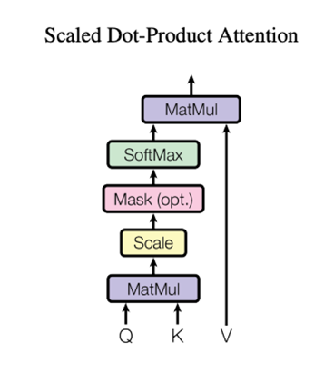
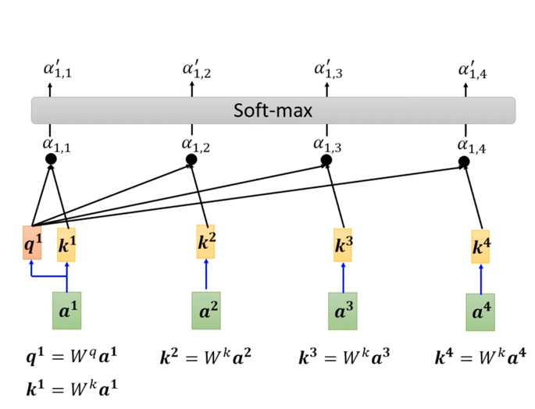
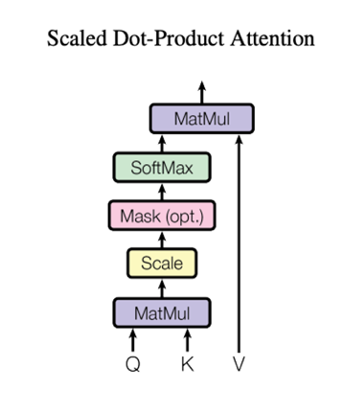
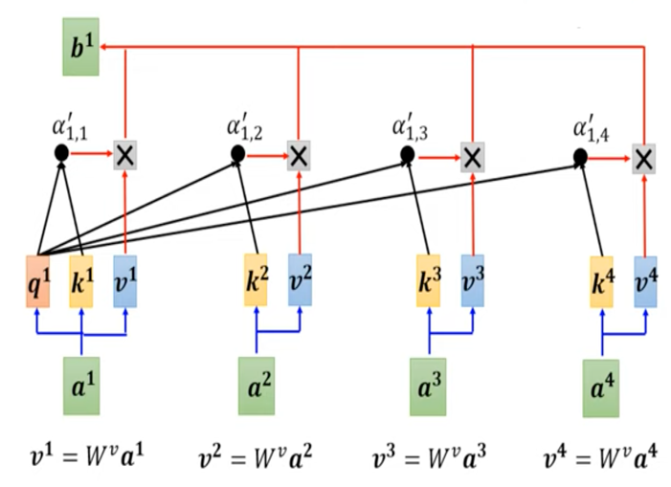
- The process in the bounding blue box, suppose that there are t query vectors and t key vectors, then this process will calculate the weights of the query vector $q^{i}$ with all key vectors $k^{1}$, $k^{2}$, $k^{3}$, …. , $k^{t-1}$, $k^{t} to obtain {α^{'}}_{i,1}$, ${α^{'}}_{i,2}$, ${α^{'}}_{i,3}$, …, ${α^{'}}_{i,t}$, where i = 1, 2, 3,.., t.
- The process of the scaled dot-product attention. Suppose that the input of the scaled dot-product attention (self-attention mechanism) consists of t query vectors, t key vectors and t value vectors, then the scaled dot-product attention (self-attention mechanism) will produce t output vectors ($b^{1}$, $b^{2}$, $b^{3}$, …, $b^{t-1}$, $b^{t}$). Each vector $b^{i}$ = ${α^{'}}_{i,1}×{v^{1}+ α^{'}}_{i,2}$ $×v^{2}$ + ${α^{'}}_{i,3 }×v^{3}$ + …. + ${α^{'}}_{i,t-1}×{v^{t-1}+ α^{'}}_{i,t}$ $×v^{t}$, where i = 1,2,3, …. , t.
Fig 34. An example of the scaled dot-product attention (self-attention mechanism). [26][27]

Figure 34(b) illustrates the process of the scaled dot-product attention. From Figure 34(a), we have already calculated the weights ${α^{'}}_{i,1}$, ${α^{'}}_{i,2}$, ${α^{'}}_{i,3}$, …, ${α^{'}}_{i,4}$, where i = 1, 2, 3, 4. Next, we utilize those weights to calculate $b^{1}$, $b^{2}$, $b^{3}$, $b^{4}$. $b^{i}$ is calculated by the linear combination of the value vectors $v^{1}$, $v^{2}$, $v^{3}$, $v^{4}$. For example, $b^{1}$ = ${α^{'}}_{1,1}× v^{1}+ {α^{'}}_{1,2}$ $×$ $v^{2}$ + ${α^{'}}_{1,3}$ $×$ $v^{3}$ + ${α^{'}}_{1,4}$ $×$ $v^{4}$ as shown in Figure 34(b). F$or convenience$, Figure 34(b) only demonstrates how to compute $b^{1}$. The rest operations for calculating $b^{2}$, $b^{3}$, $b^{4}$ are omitted ($b^{2}$ = ${α^{'}}_{2,1}× v^{1}+ {α^{'}}_{2,2}$ $×$ $v^{2}$ + ${α^{'}}_{2,3}$ $×$ $v^{3}$ + ${α^{'}}_{2,4}$ $×$ $v^{4}$, $b^{3}$ = ${α^{'}}_{3,1}× v^{1}+ {α^{'}}_{3,2}$ $×$ $v^{2}$ + ${α^{'}}_{3,3}$ $×$ $v^{3}$ + ${α^{'}}_{3,4}$ $×$ $v^{4}$, and $b^{4}$ = ${α^{'}}_{4,1}× v^{1}+ {α^{'}}_{4,2}$ $×$ $v^{2}$ + ${α^{'}}_{4,3}$ $×$ $v^{3}$ + ${α^{'}}_{4,4}$ $×$ $v^{4} ).$ In conclusion, suppose that the input of the scaled dot-product attention (self-attention mechanism) consists of t query vectors, t key vectors and t value vectors, then the scaled dot-product attention (self-attention mechanism) will produce t output vectors ($b^{1}$, $b^{2}$, $b^{3}$, …, $b^{t-1}$, $b^{t}$). Each vector $b^{i}$ = ${α^{'}}_{i,1}×{v^{1}+ α^{'}}_{i,2}$ $×v^{2}$ + ${α^{'}}_{i,3 }×v^{3}$ + …. + ${α^{'}}_{i,t-1}×{v^{t-1}+ α^{'}}_{i,t}$ $×v^{t}$, where i = 1,2,3, …. , t. The process of the scaled dot -product attention can be formulated as in (9) [26]:
Attention(Q, K, V) = softmax($\frac{QK^{T}}{\sqrt{d_{k}}}$)V,
(9)
where $\sqrt{d_{k} } is the scaling factor, and$ $d_{k}$ is the dimension of the key vector and the query vector. Key vectors, query vectors and value vectors are aggregated into the K matrix, the Q matrix and the V matrix respectively. By conducting the matrix operation, the outputs of the self-attention can be obtained.
Multi-head attention
Multi-head attention (multiple heads, the number of heads ($N_{h})$is set manually) contains several scaled dot-product attentions (self-attentions). Figure 35 shows an example of the multi-head attention. Figure 35 utilizes the two-head attention ($N_{h}$ = 2) as an example. Figure 35(a) demonstrates how to calculate $b^{i,1}$. From Figure 35(a), we can observe that after finish calculating $q^{i}$, $q^{j}$, $k^{i}$, $k^{j}$, $v^{i}$, $v^{j}$, they are then split into two heads ($N_{h}$ = 2) respectively ($q^{i,1}$, $q^{i,2}$, $q^{j,1}$, $q^{j,2}{,k}^{i,1}$, $k^{i,2}$, $k^{j,1}$, $k^{j,2}$, $v^{i,1}$, $v^{i,2}$, $v^{j,1}$, $v^{j,2},$where $q^{i,1}$ = $W^{q,1}q^{i}$, $q^{i,2}$ = $W^{q,2}q^{i}$, $k^{i,1}$ = $W^{k,1}k^{i}$ , and so on). To obtain $b^{i,1}$, we calculate the weights of the query vector $q^{i,1}$with key vectors $k^{i,1}$, $k^{j,1}$ and utilize $v^{i,1} and v^{j,1}$to calculate $b^{i,1}$ with those weights. Figure 34(b) demonstrates how to calculate $b^{i,2}$. To obtain $b^{i,2}$, we calculate the weights of the query vector $q^{i,2}$with key vectors $k^{i,2}$, $k^{j,2}$ and utilize $v^{i,2} and v^{j,2}$to calculate $b^{i,2}$ with those weights. Finally, $b^{i} is calcuated by$the linear combination of $b^{i,1}$ and $b^{i,2}$ as shown in Figure 35(c). The other multi-head attentions, where $N_{h}$ = 3,4,5,6…., are also calculated in the similar way as the two head attention.

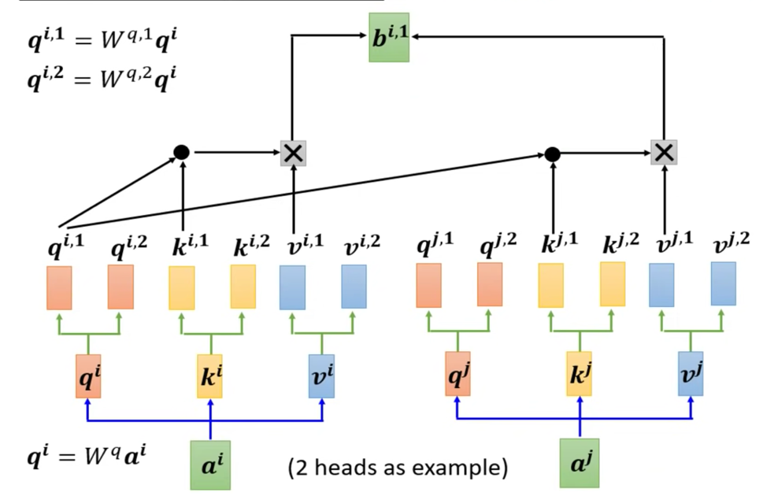
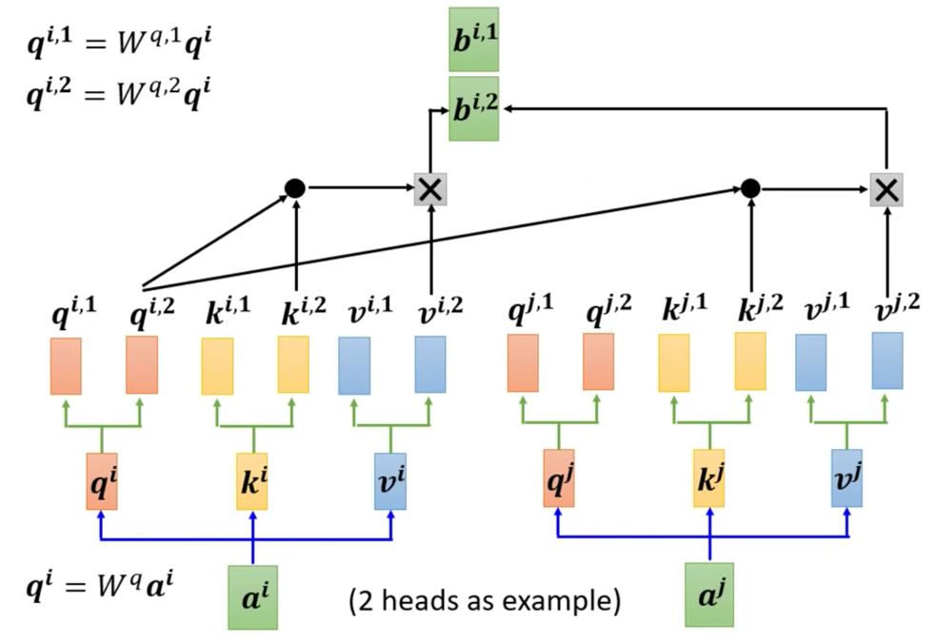
(a)The process of calculating $b^{i,1}$.
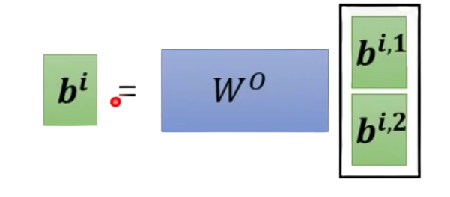
(b)The process of calculating $b^{i,2}$.
=
(c)The process of calculating $b^{i,1}$.
Fig 35. An example of the Multi-head attention.
Take the two-head attention ($N_{h}$ = 2) as an example. [27]

Encoder
The encoder consists of N same layers. Each layer contains two parts. The first part is the multi-head attention with a residual connection and a layer normalization. It can be formulated as Layer Normalization(x + multi-head attention(x)). The second part is the fully connected feed-forward network with a residual connection and a layer normalization. It can be formulated as Layer Normalization(x + feed forward(x)). A layer normalization [28] normalizes the input vector of the layer and obtains the normalized output vector.
Decoder
The decoder also consists of N same layers. Each layer is a bit different from the layer of the encoder. It contains two parts. The first part is the masked multi-head attention with a residual connection and a layer normalization. It can be formulated as Layer Normalization(x + masked multi-head attention(x)). The second part is the multi-head attention with a residual connection and a layer normalization. It can be formulated as Layer Normalization(x + multi-head attention(x)). The third part is the fully connected feed-forward network with a residual connection and a layer normalization. It can be formulated as Layer Normalization(x + feed forward(x)).
Applications of the Transformer to the NLP task
There are many applications of the Transformer to the NLP task, one of them is the language translation. Suppose we want to translate Mandarin spoken by a Taiwanese to English. Each word spoken by a Taiwanese is expressed as a token, and each token is then converted through a word embedding to a vector. Those vectors, which are $α^{1}, α^{2}, α^{3}, … α^{n}$as introduced above, serve as the input of the Transformer. The role of the encoder is to encode the information of the speaking content. In other words, the encoder tries to understand the speaking content. The decoder then translates Mandarin to English based on the information encoded by the decoder. Another example is the question-answering task. Each word of the question is expressed as a token, and each token is transformed to a vector. Those vectors are the input of the Transformer. The encoder encodes the information of the question, which means the encoder attempts to understand the question. The decoder then answers the question based on the information encoded by the encoder. From those two examples, we can observe that the Transformer is very robust, it is able to solve different NLP tasks with some modifications.

3.6 General Structure of Transformer-based Methods
The Transformer has been detailly illustrated from the above paragraph, now I introduce the general structure of Transformer-based semantic segmentation methods. Transformer-based semantic segmentation methods also follow the encoder-decoder design discipline. The encoders of Transformer-based semantic segmentation methods are designed in Transformer-like architecture, and the decoders of Transformer-based semantic segmentation methods are designed in Transformer-like architecture or FCN architecture. After introducing the general Transformer-based structure design for semantic segmentation, now let’s look at several famous Transformer-based encoder/backbone designs.

3.7 Backbones/Encoders of Transformer-based Methods

3.7.1 Backbone 1: Vision Transformer (ViT)
In this section (Backbones), we focus on the designs of several backbones/encoders for the semantic segmentation models. In the next section (Methods), we will introduce various semantic segmentation models based on the backbones. The first transformer backbone that is broadly used for various computer vison tasks is called the Vison Transformer (ViT) [29]. The ViT, which is trained for the image classification task so as to learn the ability of extracting the information of the images, consists of the transformer encoder designed for the natural language processing task. An image is split into multiple patches, and each patch is flattened and linear projected into a patch embedding. Each patch embedding is then added with a position embedding to obtain an input vector for the transformer encoder. Note that each image patch is a token, which is analogous to a word for the NLP task. The overall structure of the ViT is shown in Figure 36. From Figure 36, we can observe that a learnable classification embedding $e_{o}$, which is the first input vector (from left to right) of the transformer encoder, is incorporated in the ViT to conduct image classification.
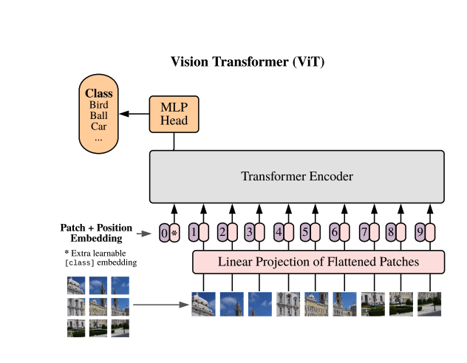
Fig 36. The overall structure of the ViT. An image is split into multiple patches. Each patch is linear projected into an embedded vector, and each embedded vector is added with a positional embedding to form an input vector for the transformer encoder. Furthermore, a learnable classification embedding, which is the first input vector (from left to right) of the transformer encoder, is added to classify the image. [29]

To have a thorough understanding of the ViT, I will take a 2D image x $∈$ $R^{H × W × C}$ for instance, where H and W is the height and width of the 2D image and C is the channel of the 2D image. First, the 2D image is reshaped into $x_{reshape}$ $∈$ $R^{N × ( P^{2}C)}$, where N denotes the number of patches (N = H$W/P^{2}),$P stands for the height and width of the patch whose shape is squared and C is the channel of the 2D image. After reshaping, there are N tokens in total and each token’s size is $P^{2}C$. Next, each token is linear projected from dimension $P^{2}C$to D to obtain a patch embedding. Each patch embedding is then added with a 1D positional embedding to form an input vector $x_{input vector}$ $∈$ $R^{D}$ for the transformer encoder. The dimension of the input $x_{input }$ $∈$ $R^{(N+1) × D}$for the transformer encoder is (N +1) $× D$ because there are N input vectors calculated from N patches with a learnable classification embedding vector and each input vector’s dimension is $D$.

3.7.2 Backbone 2: Swin Transformer
Swin Transformer [30] is introduced after the ViT and serves as a popular backbone applied to the computer vision task. One of the difficulties that the ViT encounters is scale. Unlike words whose scales are stable, visual elements are variable in scale. However, scales of the image patches/tokens in the ViT are all fixed. Therefore, the ViT can’t handle the scale problem properly. Another difficulty is that it is very time consuming for the Transformer to process the high-resolution images. The reason is because the time complexity of the self-attention mechanism is quadratic to image size. Therefore, it takes considerable time for the vanilla Transformer to tackle the high-dense prediction tasks such as semantic segmentation. Based on those two difficulties that the vanilla Transformer has encountered, Swin Transformer is designed to overcome those problems. Swin Transformer creates hierarchical feature maps so as to capture multi-scales visual information. It begins with small-sized patch in the shallow layer of Swin Transformer and gradually merges the neighboring patches in deep layers of Swin Transformer. Furthermore, Swin Transformer just computes self-attention in each local window (each local window is bounded by four red line segments as shown in Figure 37), therefore, the computation complexity of Swin Transformer is linear to image size. With those designs, Swin Transformer is able to solve those issues mentioned above. Figure 37 shows the difference between Swin Transformer and ViT.
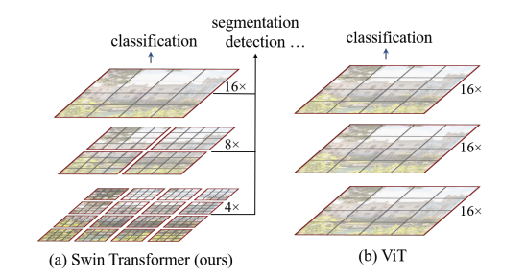
Fig 37. The comparison between Swin Transformer and ViT. (a) Hierarchical feature maps are produced in Swin Transformer so as to capture multi-scales visual information. The computational complexity is linear to image size because self-attention is calculated locally in each window (bounded by four red line segments). With the ability to extract feature maps of low and high resolution in an efficient way, Swin Transformer is very suitable for a wide range of computer vision tasks including image classification, object detection, semantic segmentation and so on. (b) ViT only extracts feature maps of a single scale. Furthermore, the time complexity is quadratic to image size because self-attention is computed in a global window (bounded by four red line segments). Therefore, ViT is not that suitable for high-dense prediction tasks compared to Swin Transformer. [30]

From Figure 37, we can observe that sizes of patches in ViT are fixed and the computational complexity of ViT is quadratic to image size because self-attention is calculated globally. After briefly introducing how Swin Transformer is designed, now let’s dive in more design details of this elaborated model. The fine design of Swin Transformer is that it shifts the window between consecutive self-attention layers. With this design, Swin Transformer can capture visual information across the boundary of two neighboring windows in the previous layer. Therefore, it enhances Swin Transformer’s ability of capturing image information. The process of shifting windows is shown in Figure 38.
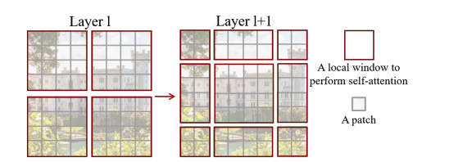
Fig 38. The process of shifting windows. In layer l, self-attention is calculated in each local window. In next layer (layer l +1), four windows in the previous layer are shifted to form new windows, and self-attention is computed in each new local window. We can observe that the new window crosses the boundary of two old windows in the previous layer. This elaborated design strengthens Swin Transformer’s power of extracting image information. [30]

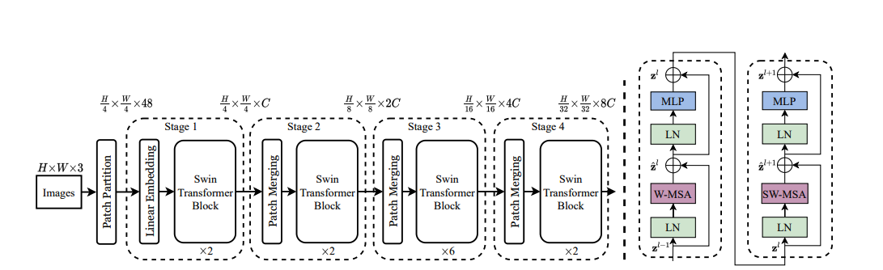
The overall architecture of the Swin Transformer is shown in Figure 39. The architecture illustrated in Figure 39 is Swin-T. There are four kinds of Swin Transformer: Swin-T, Swin-S, Swin-B, and Swin-L proposed in this paper. Those architectures vary in model size and computational complexity, but their overall design structures are similar.
(a)The architecture of the Swin Transformer (Swin-T) (b) Two consecutive Swin Transformer blocks
Fig 39. (a) The architecture of the Swin Transformer (Swin-T). (b) Two consecutive Swin Transformer blocks. MLP stands for multilayer perceptron, LN denotes layer normalization, W-MSA means multi-head self attention calculated in every local window (layer l) , and SW-MSA means multi-head self attention calculated in every shifted local window(layer l + 1). [30]

The preprocessing stage of Swin Transformer is same as ViT. An image (dimension: H$×W ×Channel$, Channel = 3) is split into multiple patches, and each patch is flattened (dimension: $P^{2}Channel$, P = 4 in Swin-T) and linear projected to obtain a linear embedding (dimension: C. In ViT section, it is denoted as D). Each linear embedding is an input vector of the Swin Transformer block in stage 1. We can observe that the vanilla Transformer block is substituted by the Swin Transformer block. The difference between the Transformer block and the Swin Transformer block is that the standard multi-head self attention mechanism (MSA) is replaced by the W-MSA (Window based multi-head self attention) or the SW-MSA (Shifted-window based multi-head self attention). We know that there are totally N (H$W/P^{2}$) patches in an image, and the dimension of each embedded vector is C. Suppose each window contains W $×$ W patches, then the computational complexity of MSA (10.1) [30] and W-MSA (10.2) [30] are:
$Ω(MSA)$ = 4N$C^{2}$ + 2$N^{2}$C, (10.1)
$Ω$(W-MSA)= 4N$C^{2}$ + 2$W^{2}N$C. (10.2)
From the formula, we can observe that MSA is quadratic to N, and W-MSA is linear to N when W is set as a constant (Generally N $≫W$, W is set as 7 in this paper.). If we all utilize W-MSA to calculate the self-attention, we are not able to explore the relationship across the boundary of two neighboring windows. Therefore, the second Transformer block, which is concatenated directly with the first Transformer block, needs to shift the windows from the first Transformer block and calculate self-attention in those shifted-local windows. This process is abbreviated as SW-MSA. The shifting rule is that we have to move the windows from the first Transformer block by ($floor\left(\frac{W}{2}\right), floor(\frac{W}{2})$) pixels to form the new windows in the second Transformer block. An example of how to shift the window has already been demonstrated in Figure 38. In summary, the procedure of two consecutive transformer blocks can be formulated as in (11) [30]
(11)
${\hat{z}}^{l}$ = W-MSA (LN (${\hat{z}}^{l-1}$)) + $z^{l-1}$,
$z^{l}$= MLP (LN (${\hat{z}}^{l}$)) + ${\hat{z}}^{l}$,
${\hat{z}}^{l+1}$ = SW-MSA (LN ($z^{l}$)) + $z^{l}$,
$z^{l+1}$ = MLP (LN (${\hat{z}}^{l+1}$)) + ${\hat{z}}^{l+1}$,
where the first two equations illustrate the calculating process of the first Transformer block, and the last two equations demonstrate the computing procedure of the second Transformer block.

3.7.3 Backbone 3: BEIT
The previous transformer backbones that are introduced are supervised vision models. In this section, I will introduce a self-supervised vision model called Bidirectional Encoder representation from Image Transformers, which is abbreviated as BEIT [31]. The difference between self-supervised learning and supervised learning is that self-supervised learning is trained on unlabeled data and supervised learning is trained on labeled data. The benefit of supervised learning is that it saves the cost of annotating data in high quality because it doesn’t require any labeled data. The design inspiration of BEIT derives from BERT in NLP field. BERT is a very powerful model that can be applied to various tasks in NLP field. Various tasks include question answering, sentiment analysis and so on. BERT is pre-trained with a masked language modeling task, it randomly masks some tokens (words) in a text and aims to recover those masked tokens to form a complete text. Similar to BERT, BEIT is pre-trained with a masked image modeling task. It randomly masks some tokens (image patches) in an image and tries to recover those masked image patches. The overall architecture of BEIT is shown in Figure 40.
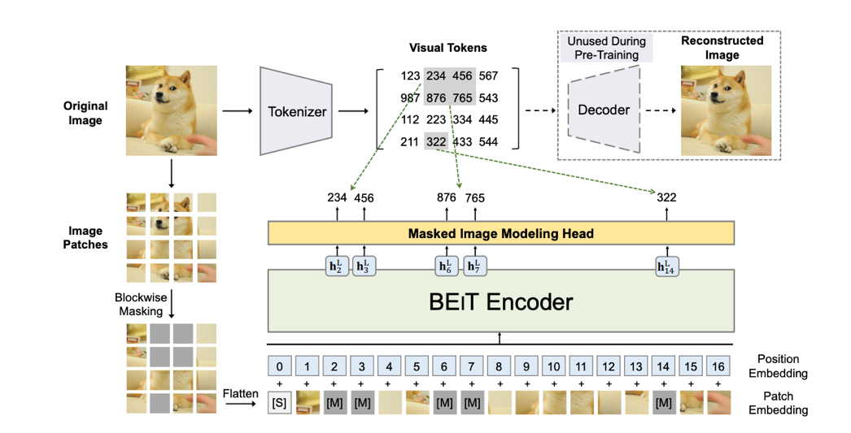
Fig 40. The overall structure of BEIT. The image is split into multiple patches and those patches have their visual tokens respectively. Those visual tokens are learned through the variational autoencoder (VAE). The function of the VAE is to encode image patches as visual tokens and utilize those visual tokens to reconstruct the original image. Therefore, with the assistance of the VAE, visual tokens, which are code names for image patches, can be obtained. After splitting and tokenizing the image, some image patches of the image are then randomly masked, which are denoted by gray patches in this figure, and substituted by a special mask embedding. Those patches are then fed into a Transformer encoder (BEIT encoder) to produce encoded representations of the image patches. A softmax classifier is then applied to each mask image’s encoded representation ($h_{2}^{L}$, $h_{3}^{L}$, $h_{6}^{L}$, $h_{7}^{L}$, $h_{14}^{L}$ in this figure) to estimate accurate visual tokens of the masked image patches. With this self-supervised BEIT learning approach, the pretrained BEIT can capture a lot of information from the image. Therefore, it can serve as a powerful encoder/backbone for computer vision tasks. [31]

From Figure 40, we can observe that the image is split into several image patches. Furthermore, it is tokenized through discrete variational autoencoder (VAE) [32] to obtain discrete visual tokens, which serve as code names, for all image patches. All image patches of the image are then fed into a standard Transformer encoder with some image patches randomly substituted by a special mask embedding. The output vectors of the Transformer encoder are encoded representations of the image patches. Then a softmax classifier (masked image modeling head) is utilized for each masked image patch’s encoded representation so as to predict the correct visual tokens of the masked image patches. This is the overall BEIT pretraining process. After BEIT is pretrained, it is able to extract robust information of the image. Therefore, now we can concatenate downstream task layers to the pretrained BEIT and fine-tune the whole structure to conduct the downstream task. There are various downstream tasks that BEIT can be applied to, which include semantic segmentation, image classification, object detection and so on.

3.7.4 Backbone 4: MAE
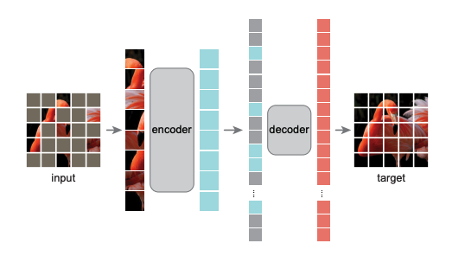
A masked autoencoder (MAE) [33] was proposed in 2022, which is a very recent design. MAE is also a self-supervised vision model, it consists of an encoder and a decoder and the design of the encoder and the decoder is asymmetric. Similar to BEIT, MAE also splits an image into image patches and randomly masks some of the image patches with mask tokens. The MAE architecture is illustrated in Figure 41.
Fig 41. The overall structure of MAE. The image is split into multiple patches and some image patches of the image are randomly masked by mask tokens, which are denoted by gray patches in this figure. Note that the masking ratio is set high (e.g., 75%) so as to boost the performance of the model and reduce the computational cost. Those unmasked patches are fed into the MAE encoder (ViT) to produce the latent representation of unmasked image patches. The latent presentation of unmasked image patches and the mask tokens are then fed into the lightweight decoder so as to reconstruct the corrupted image by predicting the pixel values for every masked image patch. The is the overall process of pre-training. The pretrained MAE encoder can be applied to various downstream tasks including semantic segmentation, object detection, and so on. Note that the MAE decoder is not utilized when conducting downstream tasks. [33]

From Figure 41, we can observe that only image patches without masking are fed into the encoder, which is a ViT. The output of the encoder is the latent representation of the unmasked image patches. The latent representation of the unmasked image patches and mask tokens are then fed into a lightweight decoder, and the lightweight decoder will reconstruct the corrupted image based on them. The lightweight decoder consists of several Transformer blocks. It reconstructs the corrupted image by estimating the pixel values for every masked image patch. Note that the decoder designed in a lightweight manner can decrease the computational cost effectively. The reason is because all tokens including mask tokens and the latent representation of the unmasked image patches are all fed into the decoder.
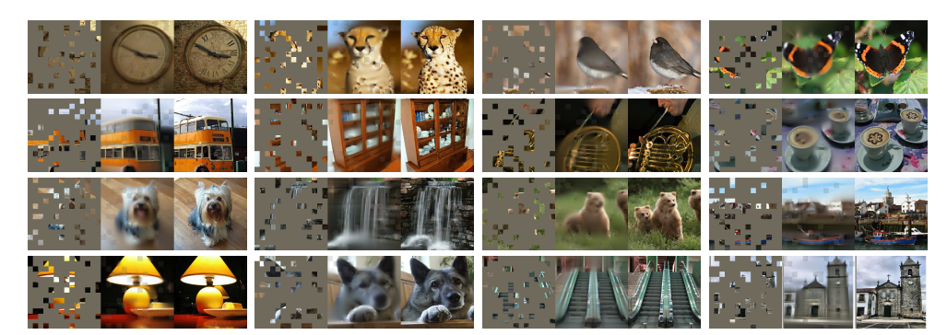
According to this paper, random masking with a high masking ratio is favorable when training the MAE. There are several benefits when training the model with a high masking ratio. The first benefit is that the time and memory cost for pretraining the MAE can be reduced. The reason is because the encoder just processes unmasked image patches. Therefore, significantly large encoders can be trained more efficiently with most of the image patches not fed into them. The second benefit is that it can boost the predicted accuracy of the model. The reason is because random masking with a high masking ratio can produce highly sparse image input as shown in Figure 41. This highly sparse input can make MAE learn high level information such as scenes, objects, and parts so as to recover the corrupted image. In other words, MAE is able to extract more useful image information when it is trained with a high masking ratio. On the contrary, if we random mask the image with a low masking ratio, then the model can just recover the corrupted image just by extrapolating from the neighboring unmasked patches without learning much high-level information that is useful.
Fig 42. Those images are from the ImageNet validation set. In this figure, MAE is pretrained on ImageNet and images are masked with the 80% masking ratio. There are 16 triplets in this figure. Each triplet consists of three images, the left image is the masked image, the middle image is the reconstructed image produced by MAE, and the right image is the ground-truth. [33]
Figure 42 shows the reconstructing performance of pre-training MAE with a high masking ratio. Those images are from ImageNet validation set. From Figure 42, we can observe that MAE can approximately recovers the corrupted image although most of the image patches are masked.
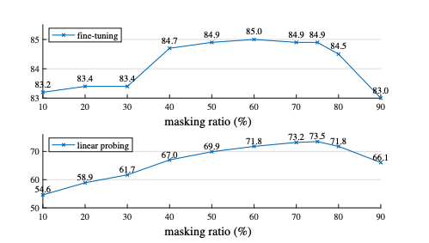
Figure 43 shows the performance of fine-tuning and linear probing for MAE pretrained with different masking ratio. The performance comparison is evaluated on InageNet-1K validation set. From Figure 43, we can see that the masking ratio between 70% and 80% results in very good performance in both fine-tuning and linear probing. This experimental result confirms that a high masking ratio can leads to a better performance of the model. However, it has to be set moderately, if the masking ratio is set up to 90 %, then the performance of the model will decrease instead of increasing.
Fig 43. Performance comparison of fine-tuning and linear probing for MAE pretrained with different masking ratio. MAE pretrained with a high masking ratio (between 70% and 80%, 75% is the best setting according to this figure) that is set moderately can lead to well performance for both fine-tuning and linear probing. The y-axes for both plots are the validation accuracy evaluated on the ImageNet-1K. [33]

3.8 Transformer-based Semantic Segmentation Methods
After introducing the Transformer backbones (encoders) that extract rich information from images, it’s time to introduce several methods/models designed for the semantic segmentation task based on the Transformer backbones.

3.8.1 Method 1: SETR
SEgmentation TRansformer (SETR)[34] is made of an encoder and a decoder. Authors in [34] employed ViT as SETR’s backbone/encoder to encode the semantic information of the image, and they proposed three decoder designs to conduct the semantic segmentation from the encoded information. The overall structure of SETR is visualized in Figure 44:
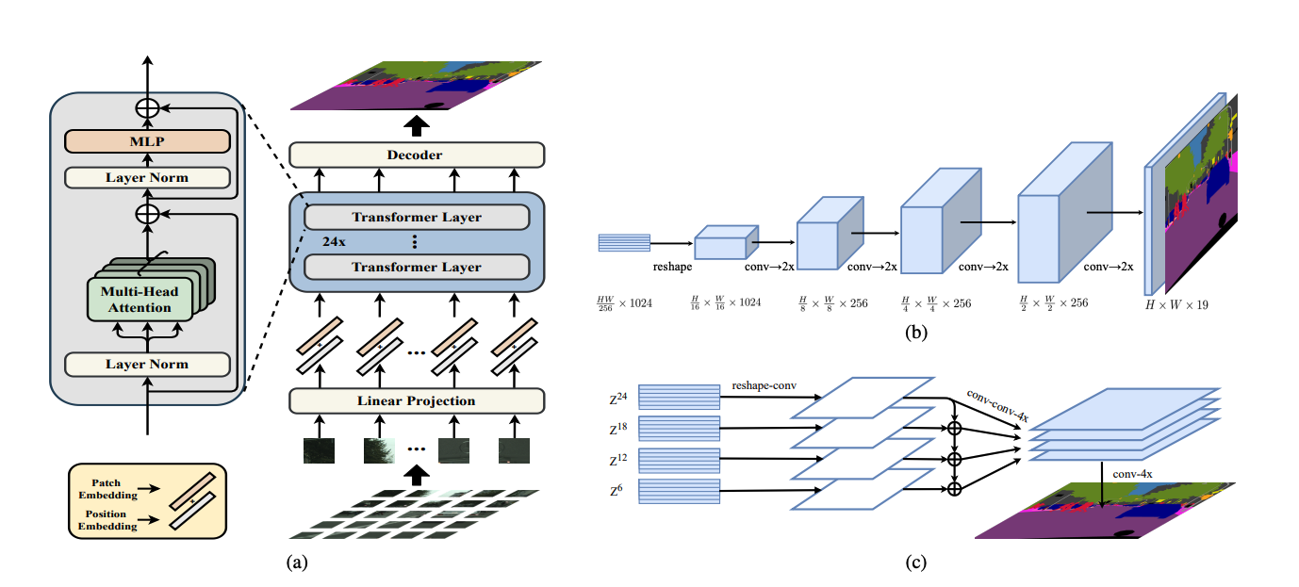
Fig 44. The overall structure of SETR. Three decoder designs are proposed in this paper. (a) The structure of the encoder is same as ViT, it is utilized to extract rich information of the image. (b) Decoder design 2 (SETR-PUP) : upsample progressively. (c) Decoder design 3 (SETR-MLA) : aggregation of multi-level features. [34]

The first decoder design proposed in this paper is naive upsampling. The output of the encoder E is two-dimensional (dimension: $\frac{HW}{256}$ $×$ D), and the predicted segmentation map that we want to produce is three-dimensional. Therefore, E is reshaped to three-dimensional at first (dimension: $\frac{H}{16}$ $×$ $\frac{W}{16}$ $×$D), where D is the dimension of each output encoded vector. Next, E (dimension: $\frac{H}{16}$ $×$ $\frac{W}{16}$ $×$D) is projected to $E^{'}$(dimension: $\frac{H}{16}$ $×$ $\frac{W}{16}$ $× N_{cls}$), where $N_{cls}$ is the number of classes of the semantic segmentation dataset. Then $E^{'}$ is bilinearly upsampled to obtain the segmentation map M (dimension: $H× W× N_{cls}$ , it is upsampled to the original image resolution). Finally, a classification layer with pixel-wise cross-entropy loss is applied to the segmentation map M to form the predicted result. This decoder is named as SETR-Naïve. The second design upsamples the feature map progressively instead of upsampling the feature map directly to the original image resolution. The benefit of upsampling progressively is that it can decrease noisy predictions. Note that the upsampling rate is restricted to 2$×$. The second decoder is named as SETR-PUP, which is shown in Figure 44(b). The third decoder aggregates multi-level features to conduct semantic segmentation. The structure of the third decoder, which is named as SETR-MLA, is shown in Figure 44(c).

3.8.2 Method 2: Segmenter
Segmenter [35] also consists of an encoder and a decoder. Authors in [35] also utilized ViT as Segmenter’s backbone/encoder to encode the semantic information of the image, and they proposed a mask decoder that can conduct semantic segmentation based on the encoded information. The structure of the Segmenter is shown in Figure 45.
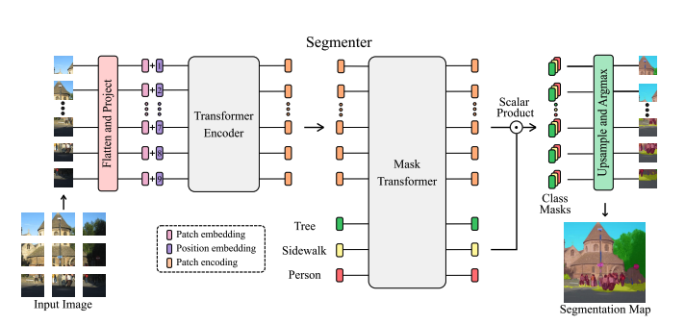
Fig 45. The overall structure of the Segmenter. The structure of the encoder is same as ViT, it is utilized to extract rich information of the image. The structure of the decoder is a mask transformer. The output of the encoder and the learnable class embeddings are fed into the decoder to estimate the segmentation map. [35]

We can observe that the encoder structure is same as ViT as shown in Figure 45 , which has been illustrated in the previous section. Therefore, we just focus on the decoder design of the Segmenter in this section. The decoder of the Segmenter is a mask transformer. A set of $N_{c}$ learnable class embeddings c = [$c_{1}, c_{2}, c_{3}, … c_{N}]$ $∈$ $R^{N_{c} × D}$ are required for the decoder, where $N_{c}$ is the number of classes and D is the dimension of each encoded vector (patch encoding). From Figure 45, we can see that encoded vectors for all image patches and learnable class embeddings are both fed into the decoder. The mask transformer then generates $N_{c}$masks by calculating the scalar product between encoded vectors e $∈$ $R^{N_{e} × D}$ and learnable class embeddings c $∈$ $R^{N_{c} × D}$, where $N_{e}$ denotes the number of patches. The scalar product procedure can be formulated as in (12):
Mask(e,c) = e$c^{T}$, (12)
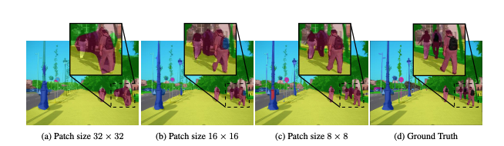
where Mask(e,c) $∈$ $R^{N_{e} × N_{c}}$. After obtaining $N_{c}$masks, each mask is reshaped into a two-dimensional mask $m_{2D}$ $∈$ $R^{\frac{H}{P}×\frac{W}{P} }$ to form $m_{3D}$ $∈$ $R^{\frac{H}{P}×\frac{W}{P}×N_{c} }. { m}_{3D}$ is then bilinearly upsampled to a $feature maps: f_{3D} ∈ R^{H × W ×{ N}_{c} }$whose H and W are same as the original image. A softmax classifier is then applied to the feature map $f_{3D}$ to obtain the final segmentation result. This is the overall procedure of the Segmenter. Note that the performance of the Segmenter is better with the smaller input image patch sizes, Figure 46 shows the comparison of segmented predictions with different patch sizes. From Figure 46, we can observe that patch size 8 $×$8 leads to the best performance of the semantic segmentation compared to the others.
Fig 46. Comparison of segmented predictions with different patch sizes. [35]

3.8.3 Method 3: SegFormer
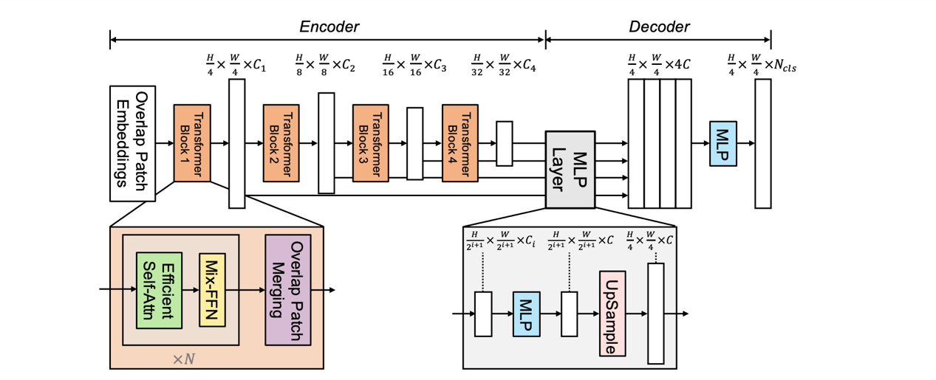
SegFormer [36] also consists of an encoder and a decoder. Both the encoder and the decoder are designed elaborately according to the characteristics of the semantic segmentation. The encoder of the SegFormer is a hierarchical transformer which can produce high-level features and low-level features. Those multi-level features generated by the encoder are then fed into the light-weight decoder of the SegFormer to conduct the semantic segmentation task. The overall structure of the SegFormer is illustrated in Figure 47.
Fig 47. The general structure of the SegFormer. It consists of an encoder which extracts high-level and low-level features and a light-weight decoder which processes both high-level and level features to make the segmented prediction. [36]

From Figure 47, we can observe that the encoder is a hierarchical structure which contains four transformer blocks and patches are merged to produce multi-level feature maps as the transformer block goes deeper. Suppose that the size of the input image is $H ×$ W $×$ 3, then the encoder can obtain four feature maps {$F^{1}, F^{2}, F^{3}, F^{4}\}$. The resolution of each feature map $F^{i}$ is $\frac{H}{2^{i+1}}$ $×$ $\frac{W}{2^{i+1}}$ $× C^{i}$, where $i ∈$ {1,2,3,4} and $C^{i}$ is the channel of the feature map. Note that $C^{i+1}$ is larger than $C^{i}$. Encoders designed in this structure with different sizes are categorized as family of Mix Transformer encoders (MiT) by the authors. There are totally 6 MiTs with different sizes proposed in this paper. The MiT with the biggest size has the best performance but it requires more time to compute. On the other hand, the MiT with the smallest size cannot have the best performance while it can predict faster. Therefore, which MiT to choose depends on whether accuracy or time is more important.
(13)
Now let’s dive into the details of MiT. Previous works utilized non-overlap patch embeddings as the input of the encoder. The problem of non-overlap patch embeddings is that it can’t preserve local continuity around those patches. Therefore, the Segformer utilizes overlap patch embeddings as the input of the encoder to solve this issue. Now let’s look at the design of the transformer block. Each transformer block of the Segformer contains N Efficient self-attentions, N Mix Feed Forward Networks and an overlap patch merging, where N is a hyperparameter.
The efficient self-attention, which is the improved version of the self-attention mechanism, consists of a sequence reduction process and an original self-attention. It can decrease the computational complexity compared to the original version with the assistance of the sequence reduction process. Suppose that the length of a key input sequence K is L and a reduction ratio is R, then the computational complexity of the efficient self-attention mechanism is $O(\frac{L^{2}}{R}$). Compared to the computation complexity of the original self-attention which is $O(L^{2}$), we can see that the efficient self-attention consumes less time. The sequence reduction process is shown as in (13):
(13)
$K^{'}$= Reshape_ K ($\frac{L}{R}$, $R⋅d$),
Reduced_K = Linear_$K^{'}$($R⋅d$, $d$),
where d denotes the dimension of a query/key/value vector in the original self-attention process. The key input sequence K (dimension: L $×$ d ) that we want to reduce is first reshaped to $K^{'}($dimension: $\frac{L}{R}$ $×$ ($R⋅d)$). Next the sequence $K^{'}($dimension: $\frac{L}{R}$ $×$ ($R⋅d)$) is fed into a linear layer to obtain Reduced_K$($dimension: $\frac{L}{R}$ $×$ $d$). The Reduced_K is then utilized to calculate the self-attention. In conclusion, the sequence reduction process decreases length of a key input sequence from L to $\frac{L}{R}$, therefore, the computational complexity of the efficient self-attention mechanism can be reduced to $O(\frac{L^{2}}{R}$).
Another design in the Transformer block of the SegFormer is Mix Feed Forward Networks (Mix-FFN). As stated above, ViT utilizes positional encoding whose resolution is fixed to extract the location information. The problem is that when the image resolution in the test set is different from the training set, then the interpolation of the positional encoding is required. This process often leads to declined accuracy on the test set. To relieve this issue, the authors discard the positional encoding. They adopt another method called Mix-FFN to capture the location information for semantic segmentation. The formula of Mix-FFN is formulated as in (14) [36]:
(14)
$x_{out}$ = MLP(GELU(${Conv}_{3×3}$(MLP($x_{in}$)))) + $x_{in}$,
where MLP denotes multilayer perceptron and $x_{in}$is the output feature from the efficient self-attention. We can observe that a 3 $×$ 3 convolution is applied in (14). The purpose of utilizing a 3 $×$ 3 convolution is to retrieve the positional information. Someone may be curious about whether a 3 $×$ 3 convolution is enough to extract the location information for the SegFormer. In this paper, the authors have conducted experiments to demonstrate that a 3 $×$ 3 convolution is adequate.
The last step in the transformer block is overlap patch merging, it transforms the feature map from $F_{i}$ (dimension: $\frac{H}{D_{i}} × \frac{W}{D_{i}} × C_{i})$ to $F_{i+1}$ (dimension: $\frac{H}{{2D}_{i}} × \frac{W}{{2D}_{i}} × C_{i+1})$ by merging overlap patches. The decoder of the SegFormer is lightweight and consists only of multilayer perceptron (MLP) layers. The lightweight characteristic of the decoder can enable the SegFormer to predict faster. The reason why the decoder can be designed in a lightweight manner is because the MiT provides a large effective receptive field (ERF). ERFs of the four encoder stages and the decoder heads for both DeepLabv3+ and SegFormer on the Cityscapes dataset are visualized in Figure 48. As illustrated in the previous section, DeepLabv3+ utilizes the CNN-based encoder to extract the image information. From Figure 48, we can observe that at stage 4, which is the deepest stage of the encoder, the ERF of SegFormer is larger than DeepLabv3+. This phenomenon indicates that the Transformer-based encoder can provide more global information compared to the CNN-based encoder. Furthermore, due to the hierarchical design of MiT, the ERF of MiT is getting larger and larger as stage goes deeper. This characteristic enables the MiT to capture robust image information including both local and non-local. In conclusion, a light-weight decoder is sufficient to conduct precise segmented prediction based on the robust information extracted by the powerful MiT. On the other hand, a light-weight decoder is not enough for the CNN -based encoder because of its limited receptive field.

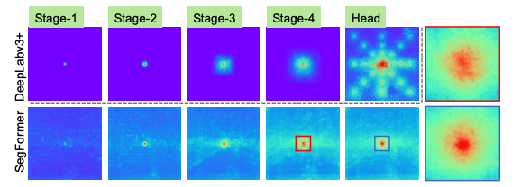
Fig 48. Effective receptive fields (ERFs) of the four encoder stages and the decoder heads for both DeepLabv3+ and SegFormer. Those models are trained on the Cityscapes dataset. [36]

The overall procedure of the decoder of the SegFormer is formulated as in (15) [36]:

${\hat{F}}_{i}$= Linear($C_{i}$, C)($F_{i}$), $∀i$
${\hat{F}}_{i}$= Upsample($\frac{H}{4}$ $× \frac{W}{4}$)(${\hat{F}}_{i}$), $∀i$
(15)
F = Linear(4C, C)(Concat(${\hat{F}}_{i}$)), $∀i$
M = Linear(C, $N_{cls}$)(F).

The first step utilizes an MLP layer to transform multi-level feature maps with different channel dimensions to multi-level feature maps with same channel dimensions. To be more specifically, it transforms multi-level feature maps {$F^{1} , F^{2}, F^{3}, F^{4}\}$ whose dimensions are {$\frac{H}{4}$ $×$ $\frac{W}{4}$ $×C^{1} , {\frac{H}{8} × \frac{W}{8} ×C}^{2}, {\frac{H}{16} × \frac{W}{16} × C}^{3}, \frac{H}{32} × \frac{W}{32} ×C^{4}\}$ to {${\hat{F}}^{1} , {\hat{F}}^{2}, {\hat{F}}^{3}, {\hat{F}}^{4}\}$ whose dimensions are {$\frac{H}{4}$ $×$ $\frac{W}{4}$ $× C , \frac{H}{8}$ $×$ $\frac{W}{8}$ $× C, \frac{H}{16}$ $×$ $\frac{W}{16}$ $× C, \frac{H}{32} × \frac{W}{32} × C \}$. The second step upsamples {${\hat{F}}^{1} , {\hat{F}}^{2}, {\hat{F}}^{3}, {\hat{F}}^{4}\}$to dimension $\frac{H}{4}$ $×$ $\frac{W}{4}$ $× C$. The third step concatenates all feature maps {${\hat{F}}^{1} , {\hat{F}}^{2}, {\hat{F}}^{3}, {\hat{F}}^{4}\} (dimension: \frac{H}{4}$ $×$ $\frac{W}{4}$ $× 4C )$and utilizes a MLP layer to fuse all feature maps to obtain the fused feature F ($dimension: \frac{H}{4}$ $×$ $\frac{W}{4}$ $× C$). The final step utilizes another MLP layer to transform the fused feature F to the segmentation mask M ($dimension: \frac{H}{4}$ $×$ $\frac{W}{4}$ $× N_{cls}$), where $N_{cls}$ is the number of classes of the semantic segmentation dataset.

- Comparisons
This section summarizes different methods with different backbones and their performances on the segmentation datasets that are widely utilized.

Table 2. Comparison of different segmentation models on the Cityscapes dataset.
Methods | Backbones | Techniques | Advantages | mIoU
DeepLabv3+  [16] | ResNet-101  [9] | 1.Depthwise atrous seperable convolution  2.ASPP | Able to exploit multi-scale features by ASPP.  Can increase the receptive field while maintaining the spatial resolution of the image.  Depthwise seperable convolution is more computationally efficient than the traditional convolution. | validation set:  80.9
CCNet  [24] | ResNet-101  [9] | Criss-cross attention block | Capture the global information in an efficient way. (time /space complexity is $Ο\left(\left(H × W\right) × (H+W-1)\right) )$ | test set:  81.9  validation set: 81.3
SETR-PUP  [34] | ViT  [29] | Change the CNN-based backbone to the Transformer-based backbone. | It is very easy to capture the global information because of the ViT, which is a transformer encoder designed for the field of the computer vision. | test set:  81.08  validation set: 82.2
Segmenter  [35] | ViT  [29] | Mask transformer decoder | The decoder is specifically designed for the semantic segmentation. | validation set:  81.3
SegFormer  [36] | MiT-B5  (The largest MiT model)  [36] | 1.Efficient self-attention  2. Mix – FFN  3.Overlap patch merging | Powerful transformer encoder that can extract rich information of the image for the semantic segmentation. | test set:  82.2 validation set: 84.0

Table 3. Comparison of different segmentation models on the ADE20K dataset.
Methods | Backbones | Techniques | Advantages | mIoU
DeepLabv3+  [16] | ResNet-101  [9] | 1.Depthwise atrous seperable convolution  2. ASPP | Able to exploit multi-scale features by ASPP.  Can increase the receptive field while maintaining the spatial resolution of the image.  Depthwise seperable convolution is more computationally efficient than the traditional convolution. | validation set:  44.1
EncNet  [22] | ResNet-101  [9] | 1.Context encoding module  2.SE loss | Because EncNet has the prior knowledge of the scene (e.g. bedroom), so it can refine categories of objects in the image to specific categories (e.g. bed, floor, table). With the refinement of the possible categories, the predicted accuracy increases. | validation set:  44.65
CCNet  [24] | ResNet-101  [9] | Criss-cross attention block | Capture the global information in an efficient way. (time/space complexity is $Ο\left(\left(H × W\right) × (H+W-1)\right) )$ | validation set: 45.22
OCRNet  [25] | ResNet-101  [9] | OCR | OCR is more powerful than ASPP, it aggregates the information of different object regions for each pixel. | validation set: 45.3
SETR-MLA  [34] | ViT  [29] | Change the CNN-based backbone to the Transformer-based backbone. | It is very easy to capture the global information because of the ViT, which is a transformer encoder designed for the field of the computer vision. | validation set: 50.28
Segmenter  [35] | ViT  [29] | Mask transformer decoder | The decoder is specifically designed for the semantic segmentation. | validation set:  53.63
UperNet  [18] | Swin-L  (The largest Swin model)  [30] | 1.W-MSA and SW-MSA  2. Patches merging | Swin transformer can extract multi-scales information, ViT can’t.  Window-MSA can capture the global information in an efficient way compared to the original MSA. (Quadratic to linear) | validation set:  53.5
SegFormer  [36] | MiT-B5  (The largest MiT model)  [36] | 1.Efficient self-attention  2. Mix – FFN  3.Overlap patch merging | Powerful transformer encoder that can extract rich information of the image for the semantic segmentation. | validation set:  51.8

Table 4. Comparison of different segmentation models on the Pascal Context dataset.
Methods | Backbones | Techniques | Advantages | mIoU
DeepLabv3+  [16] | ResNet-101  [9] | 1.Depthwise atrous seperable convolution  2. ASPP | Able to exploit multi-scale features by ASPP.  Can increase the receptive field while maintaining the spatial resolution of the image.  Depthwise seperable convolution is more computationally efficient than the traditional convolution. | validation set:  48.5
EncNet  [22] | ResNet-101  [9] | 1.Context encoding module  2.SE loss | Because EncNet has the prior knowledge of the scene (e.g. bedroom), so it can refine categories of objects in the image to specific categories (e.g. bed, floor, table). With the refinement of the possible categories, the predicted accuracy increases. | validation set:  51.7
OCRNet  [25] | HRNetV2-W48  [10] | OCR | OCR is more powerful than ASPP, it aggregates the information of different object regions for each pixel. | validation set: 56.2
SETR-MLA  [34] | ViT  [29] | Change the CNN-based backbone to the Transformer-based backbone. | It is very easy to capture the global information because of the ViT, which is a transformer encoder designed for the field of the computer vision. | validation set: 55.8
Segmenter  [35] | ViT  [29] | Mask transformer decoder | The decoder is specifically designed for the semantic segmentation. | validation set:  59.0

Table 5. Comparison of different segmentation models on the COCO-Stuff dataset.
Methods | Backbones | Techniques | Advantages | mIoU
DeepLabv3+  [16] | ResNet-50  [9] | 1.Depthwise atrous seperable convolution  2. ASPP | Able to exploit multi-scale features by ASPP.  Can increase the receptive field while maintaining the spatial resolution of the image.  Depthwise seperable convolution is more computationally efficient than the traditional convolution. | full set: 38.4
OCRNet  [25] | HRNetV2-W48  [10] | OCR | OCR is more powerful than ASPP, it aggregates the information of different object regions for each pixel. | full set: 42.3
SETR  [34] | ViT  [29] | Change the CNN-based backbone to the Transformer-based backbone. | It is very easy to capture the global information because of the ViT, which is a transformer encoder designed for the field of the computer vision. | full set: 45.8
SegFormer  [36] | MiT-B5  (The largest MiT model)  [36] | 1.Efficient self-attention  2. Mix – FFN  3.Overlap patch merging | Powerful transformer encoder that can extract rich information of the image for the semantic segmentation. | full set: 46.7

From Tables 2, 3, 4, and 5, we can see that the images in the Cityscapes dataset are easier to be segmented accurately compared to the other three datasets. We can also observe that the Transformer-based methods generally have better performance compared to the FCN-based methods.

- Conclusion
Various FCN-based methods for semantic segmentation have been proposed since 2015. Those FCN-based methods include DeepLabv3+, EncNet, PSPNet, CCNet, OCRNet, and so on. They all have good performances on the semantic-segmentation task. However, FCN-based methods can not capture long-range dependencies very well, therefore, scholars all over the world try to introduce another structure called Transformer to solve this issue. Transformer can capture global information easily with the elaborated design – self-attention mechanism. Since 2020, various Transformer-based methods for semantic segmentation have been proposed. Those Transformer-based methods include SETR, Segmenter, SegFormer, and so on. Their performances on the semantic-segmentation task outperform the FCN-based methods. These results show that the Transformer-based methods can successfully work on the semantic -segmentation task and replace some of the FCN-based methods.

References
[1] https://www.v7labs.com/blog/panoptic-segmentation-guide
[2] https://www.jeremyjordan.me/evaluating-image-segmentation-models/
[3] Marius Cordts, Mohamed Omran, Sebastian Ramos, Timo Rehfeld, Markus Enzweiler, Rodrigo Benenson, Uwe Franke, Stefan Roth, and Bernt Schiele. "The cityscapes dataset for semantic urban scene understanding." Proceedings of the IEEE Conference on Computer Vision and Pattern Recognition (CVPR), 2016, pp. 3213-3223
[4] Bolei Zhou, Hang Zhao, Xavier Puig, Sanja Fidler, Adela Barriuso, and Antonio Torralba. "Scene parsing through ade20k dataset." Proceedings of the IEEE Conference on Computer Vision and Pattern Recognition (CVPR), 2017, pp. 633-641
[5] Roozbeh Mottaghi, Xianjie Chen, Xiaobai Liu, Nam-Gyu Cho, Seong-Whan Lee, Sanja Fidler, Raquel Urtasun, and Alan Yuille. "The role of context for object detection and semantic segmentation in the wild." Proceedings of the IEEE Conference on Computer Vision and Pattern Recognition (CVPR), 2014, pp. 891-898
[6] Caesar, Holger, Jasper Uijlings, and Vittorio Ferrari. "Coco-stuff: Thing and stuff classes in context." Proceedings of the IEEE Conference on Computer Vision and Pattern Recognition (CVPR), 2018, pp. 1209-1218
[7] Dumoulin, Vincent, and Francesco Visin. "A guide to convolution arithmetic for deep learning." stat 1050 (2018): 11.
[8] Tammina, Srikanth. "Transfer learning using vgg-16 with deep convolutional neural network for classifying images." International Journal of Scientific and Research Publications (IJSRP) 9.10 (2019): 143-150.
[9] Kaiming He, Xiangyu Zhang, Shaoqing Ren, and Jian Sun. "Deep residual learning for image recognition." Proceedings of the IEEE Conference on Computer Vision and Pattern Recognition (CVPR), 2016, pp. 770-778
[10] Ke Sun, Yang Zhao, Borui Jiang, Tianheng Cheng, Bin Xiao, Dong Liu, Yadong Mu, Xinggang Wang, Wenyu Liu, Jingdong Wang. "High-resolution representations for labeling pixels and regions." arXiv preprint arXiv:1904.04514 (2019).
[11] Long, Jonathan, Evan Shelhamer, and Trevor Darrell. "Fully convolutional networks for semantic segmentation." Proceedings of the IEEE Conference on Computer Vision and Pattern Recognition (CVPR), 2015, pp. 3431-3440
[12] https://www.jeremyjordan.me/semantic-segmentation/

[13] Ronneberger, Olaf, Philipp Fischer, and Thomas Brox. "U-net: Convolutional networks for biomedical image segmentation." International Conference on Medical image computing and computer-assisted intervention (pp. 234-241). Springer, Cham, 2015.
[14] Yu, Fisher, and Vladlen Koltun. "Multi-scale context aggregation by dilated convolutions." ICLR. 2016.
[15] Liang-Chieh Chen, George Papandreou, Iasonas Kokkinos, Kevin Murphy, and Alan L. Yuille. "Deeplab: Semantic image segmentation with deep convolutional nets, atrous convolution, and fully connected crfs." IEEE transactions on pattern analysis and machine intelligence 40.4 (2017): 834-848.
[16] Liang-Chieh Chen, Yukun Zhu, George Papandreou, Florian Schroff, and Hartwig Adam. "Encoder-decoder with atrous separable convolution for semantic image segmentation." Proceedings of the European Conference on Computer Vision (ECCV), 2018, pp. 801-818
[17] https://chih-sheng-huang821.medium.com/ %E5%8D%B7%E7%A9%8D%E7%A5%9E%E7%B6%93%E7%B6%B2%E8%B7%AF-convolutional-neural-network-cnn-1-1%E5%8D%B7%E7%A9%8D%E8%A8%88%E7%AE%97%E5%9C%A8%E5%81%9A%E4%BB%80%E9%BA%BC-7d7ebfe34b8
[18] Tete Xiao, Yingcheng Liu, Bolei Zhou, Yuning Jiang, and Jian Sun. "Unified perceptual parsing for scene understanding." Proceedings of the European Conference on Computer Vision (ECCV), 2018, pp. 418-434
[19] David Bau, Bolei Zhou, Aditya Khosla, Aude Oliva, and Antonio Torralba. "Network dissection: Quantifying interpretability of deep visual representations."
Proceedings of the IEEE Conference on Computer Vision and Pattern Recognition (CVPR), 2017, pp. 6541-6549
[20] Hengshuang Zhao, Jianping Shi, Xiaojuan Qi, Xiaogang Wang, and Jiaya Jia. "Pyramid scene parsing network." Proceedings of the IEEE Conference on Computer Vision and Pattern Recognition (CVPR), 2017, pp. 2881-2890
[21] Bolei Zhou, Aditya Khosla, Agata Lapedriza, Aude Oliva, and Antonio Torralba. "Object Detectors Emerge in Deep Scene CNNs." ICLR. 2015.
[22] Hang Zhang, Kristin Dana, Jianping Shi, Zhongyue Zhang, Xiaogang Wang, Ambrish Tyagi, and Amit Agrawal. "Context encoding for semantic segmentation." Proceedings of the IEEE Conference on Computer Vision and Pattern Recognition (CVPR), 2018, pp. 7151-7160
[23] Xiaolong Wang, Ross Girshick, Abhinav Gupta, and Kaiming He. "Non-local neural networks." Proceedings of the IEEE Conference on Computer Vision and Pattern Recognition (CVPR), 2018, pp. 7794-7803
[24] Zilong Huang, Xinggang Wang, Lichao Huang, Chang Huang, Yunchao Wei, and Wenyu Liu. "Ccnet: Criss-cross attention for semantic segmentation." Proceedings of the IEEE/CVF International Conference on Computer Vision (ICCV), 2019, pp. 603-612
[25] Yuan, Yuhui, Xilin Chen, and Jingdong Wang. "Object-contextual representations for semantic segmentation." European conference on computer vision (pp. 173-190). Springer, Cham, 2020
[26] Ashish Vaswani, Noam Shazeer, Niki Parmar, Jakob Uszkoreit, Llion Jones, Aidan N. Gomez, Łukasz Kaiser, and Illia Polosukhin. "Attention is all you need." Advances in neural information processing systems 30 (2017).
[27] https://speech.ee.ntu.edu.tw/~hylee/ml/ml2021-course-data/self_v7.pdf
[28] Ba, Jimmy Lei, Jamie Ryan Kiros, and Geoffrey E. Hinton. "Layer Normalization." stat 1050 (2016): 21.
[29] Alexey Dosovitskiy, Lucas Beyer, Alexander Kolesnikov, Dirk Weissenborn, Xiaohua Zhai, Thomas Unterthiner, Mostafa Dehghani, Matthias Minderer, Georg Heigold, Sylvain Gelly, Jakob Uszkoreit, and Neil Houlsby. "An Image is Worth 16x16 Words: Transformers for Image Recognition at Scale." International Conference on Learning Representations. 2020.
[30] Ze Liu, Yutong Lin, Yue Cao, Han Hu, Yixuan Wei, Zheng Zhang, Stephen Lin, and Baining Guo. "Swin transformer: Hierarchical vision transformer using shifted windows." Proceedings of the IEEE/CVF International Conference on Computer Vision (ICCV), 2021, pp. 10012-10022
[31] Hangbo Bao, Li Dong, Songhao Piao, and Furu Wei. "BEiT: BERT Pre-Training of Image Transformers." International Conference on Learning Representations. 2021.
[32] Kingma, Diederik P., and Max Welling. "Auto-Encoding Variational Bayes." stat 1050 (2014): 1.
[33] Kaiming He, Xinlei Chen, Saining Xie, Yanghao Li, Piotr Dollár, and Ross Girshick. "Masked autoencoders are scalable vision learners." Proceedings of the IEEE/CVF Conference on Computer Vision and Pattern Recognition. 2022.
[34] Sixiao Zheng, Jiachen Lu, Hengshuang Zhao, Xiatian Zhu, Zekun Luo, Yabiao Wang, Yanwei Fu, Jianfeng Feng, Tao Xiang, Philip H.S. Torr, and Li Zhang. "Rethinking semantic segmentation from a sequence-to-sequence perspective with transformers." Proceedings of the IEEE/CVF Conference on Computer Vision and Pattern Recognition (CVPR), 2022, pp. 16000-16009
[35] Robin Strudel, Ricardo Garcia, Ivan Laptev, and Cordelia Schmid. "Segmenter: Transformer for semantic segmentation." Proceedings of the IEEE/CVF International Conference on Computer Vision (ICCV), 2021, pp. 7262-7272
[36] Enze Xie, Wenhai Wang, Zhiding Yu, Anima Anandkumar, Jose M. Alvarez, and Ping Luo. "SegFormer: Simple and efficient design for semantic segmentation with transformers." Advances in Neural Information Processing Systems 34 (2021): 12077-12090.

